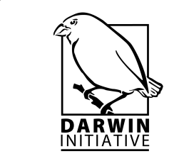 | March 2013
Enhancing the relationship between people and pollinators in Eastern India Planning, Monitoring and Evaluation System for the Centre for Pollination Studies – Version 01

By:
MAUREMOOTOO, John (John@InspiralPathways.com)
BASU, Parthiba (bparthib@gmail.com)
CRESSWELL, James (j.e.Cresswell@exeter.ac.uk)
SMITH, Barbara (bsmith@gwct.org.uk)
With the support of Calcutta University
Game & Wildlife Conservation Trust, InSpiral Pathways and University of Exeter



Contents
Contents
Acronyms and abbreviations 4
List of figures 5
List of tables 5
List of annexes 5
Acknowledgement 6
Disclaimer 6
Preferred way to cite this publication 6
Contact details of authors 6
Executive Summary 7
INTRODUCTION 17
People and pollinators – a complex issue 17
The M&E balancing act – reconciling accountability and learning 17
The Centre for Pollination Studies, the Darwin Initiative Project and its objectives 17
Planning, Monitoring and Evaluation (PME) 18
Objective of the PME System 19
Format and approach of this manual 19
Background: The PME approach used for the CPS 19
The Logical Framework Approach (LFA) 20
Outcome Mapping (OM) 22
Action Learning – putting the P in PME 27
1. MONITORING INPUTS 28
1.1. Introduction 28
1.2. Monitoring money 29
1.2.1. Daily financial records 29
1.2.2. Financial reporting 29
1.2.3. Cash advances 29
1.2.4. Co-financing 29
1.3. Monitoring resources 29
1.4. Monitoring time 29
2. MONITORING ACTIVITIES & OUTPUTS 30
2.1. Introduction 30
2.2. Monitoring activities & outputs 30
2.2.1. Project Gantt chart and logframe tracking form 30
2.2.2. Monitoring journal 31
2.2.3. Output tracking form 31
2.2.4. Output quality assurance checklists 31
2.2.5. Output evaluation forms 31
3. MONITORING OUTCOMES 31
3.1. Introduction 31
3.2. Project Vision 31
3.3. Project Mission 32
3.4. Boundary Partners 32
3.5. Outcome Challenges and Progress Markers 33
Research Partners 34
Dissemination Partners 34
The farming community in pilot sites 34
Media partners 35
Policy partners 35
Expansion partners 35
Donors 36
CPS research staff 36
CPS rural advisors 36
Calcutta University Bioscience departments 37
University of Exeter 37
GWCT 37
3.6. Strategy Map 38
3.7. Partner outcome monitoring form 39
3.8. Logframe tracking form 39
4. IMPLEMENTATION OF THE SYSTEM 40
4.1. Activity-specific monitoring 40
4.2. Ongoing monitoring 40
4.3. Periodic monitoring 40
4.4. Monitoring meetings 42
4.5. External evaluations 42
4.6. Summary of the PME process 43
References 44
Annex 1: Darwin Project Logframe and Associated documents 45
Annex 2: Templates for monitoring inputs 53
Annex 3: Templates for monitoring activities and outputs 58
Annex 4: Templates for monitoring outcomes 65

Acronyms and abbreviations
Abbreviation | Full Name
AIKS | All India Kissan Sabha
AIPSN | All India People’s Science Network
ATREE | Ashoka Trust for Research in Ecology and the Environment
BP | Boundary Partner
BES | British Ecological Society
CBD | Convention on Biological Diversity
CBD | Convention on Biological Diversity
CITES | Convention on International Trade in Endangered Species of Wild Fauna and Flora
CMS | Convention on the Conservation of Migratory Species of Wild Animals
CPS | Centre for Pollination Studies
Defra | Department for Environment, Food and Rural Affairs (UK)
DFID | Department for International Development (UK)
DST | Department of Science & Technology
FCO | Foreign and Commonwealth Office (UK)
GEF | Global Environment Facility
GWCT | Game and Wildlife Conservation Trust
ICAR | Indian Council of Agricultural Research
IISER | Indian Institute of Science Education and Research
LFA | Logical Framework Approach
MP | Member of Parliament
OFSDP | Orissa Forestry Sector Development Program
OM | Outcome Mapping
PME | Planning, monitoring and evaluation
QA | Quality assurance
S & T | Science & Technology
SAARC | South Asian Association for Regional Cooperation
ZSI | Zoological Society of India

List of figures
Figure 1: The M&E balancing act (adapted from Earl et al. 2001) 18
Figure 2: The proposed logical flow from inputs to impacts under the LFA 21
Figure 3: Schematic representation of the Darwin Project logframe illustrating the ‘logic gap’ between outputs and outcomes. The project purpose and sub-goals can be translated into outcome statements. 22
Figure 4: Representation of the relationship between a project’s spheres of control, influence and interest/concern 24
Figure 5: Boundary Partners also have Boundary Partners 24
Figure 6: Progress markers and the process of behavioural change 25
Figure 7: Six interlinked types of strategy (activity mixes). 26
Figure 8: Schematic representation of the Darwin Project logframe incorporating OM steps between outputs and outcomes. The project purpose and sub-goals can be translated into outcome statements. 27
Figure 9: Relationship between a dynamic PME system and the Action Learning Cycle. 28
Figure 10: Inputs – money, resources (including people) and time which are used to produce outputs 28
Figure 11: Spheres of control, influence and interest of the CPS. 32
Figure 12: The CPS PME System 42

List of tables
Table 1: Structure of a logframe matrix 20
Table 2: Overall strategy map for the CPS 36

List of annexes
Annex 1.1: Darwin Project Logframe 45
Annex 1.2: Project implementation timetable (intended workplan) 49
Annex 1.3: Project implementation timetable (intended workplan) 51
Annex 2.1: Daily cash book or journal 53
Annex 2.2: Half-yearly expenditure statement 53
Annex 2.3: Report of planned and actual co-finance 53
Annex 2.4: Inventory of non-expendable equipment 53
Annex 2.5: Letter of agreement/[equipment] transfer 53
Annex 2.6: Project Gantt chart 53
Annex 3.1: Logframe tracking form template (excerpt) 55
Annex 3.2: Monitoring Journal (excerpt) 57
Annex 3.3: Media tracking form template 58
Annex 3.4: Meeting tracking form template 58
Annex 3.5: Meeting participants tracking form template 58
Annex 3.6: Excerpt from a generic output quality assurance checklist 59
Annex 3.7: A generic meeting evaluation form 60
Annex 4.1: Partner Outcome Monitoring Form template 61

Acknowledgement
This activity was conducted as part of a Darwin Initiative Project - Ref: 01924 – Enhancing the relationship between people and pollinators in Eastern India. The executing agencies are: Calcutta University, Game & Wildlife Conservation Trust, and the University of Exeter.
This document makes use of various materials that were shared by OM community members on the OM learning community website http://www.outcomemapping.ca/. Without being exhaustive special thanks goes to Terry Smutylo, Simon Hearn, Sonia Herrero, Jan Van Ongevalle, Daniel Roduner and Ricardo Wilson-Grau.

Disclaimer
The presentation of material and views expressed in this document are those of the authors and do not necessarily reflect the views of the Darwin Initiative Secretariat or the project partners - Calcutta University, the Game and Wildlife Conservation Trust, or the University of Exeter.

Preferred way to cite this publication
Mauremootoo, J., Smith, B., Basu, P & J. Cresswell (2013). Planning, Monitoring and Evaluation System for the Centre for Pollination Studies (Version 01). Report submitted to the Game and Wildlife Conservation Trust under the Darwin Initiative Project: Enhancing the relationship between people and pollinators in Eastern India. Centre for Pollination Studies, Calcutta University, Kolkata, India.

Contact details of authors
Dr John Mauremootoo  Darwin Project Taxonomic and PME support  Supporting Project & Programme Planning,  Monitoring and Evaluation  Tel: +44 (0)1934 876565  Email: jmauremootoo@gmail.com  Skype: johnmaure  http://www.linkedin.com/pub/john-mauremootoo/10/b97/218 | Dr Barbara Smith  Darwin Project Leader  Senior Scientist  Farmland Ecology  The Game & Wildlife Conservation Trust  Burgate Manor,  Fordingbridge  Hampshire, SP6 1EF  UK  Tel: +44 (0) 1425 651057  Email: bsmith@gwct.org.uk
Dr James Cresswell  Darwin Project Pollination Systems Ecologist  Biosciences, College of Life & Environmental Sciences  University of Exeter  Tel: +44 (0)1392 263779  Email: j.e.Cresswell@exeter.ac.uk | Dr Parthiba Basu, Associate Professor  Darwin Project Host Country Coordinator  Ecology Research Unit  Department of Zoology &  Centre for Pollination Studies  Calcutta University  Tel. (Off.) : 033-24615445 (Extn. 276)  Web: http://www.caluniv.ac.in/academic/Zoology_final/zoology.htm

Executive Summary
Introduction: The challenges of developing a PME system for the Centre for Pollination Studies
People and pollinators – a complex issue
The conservation and management of pollinator populations for sustainable agricultural development in India is a classic example of a complex issue. There are fundamental knowledge gaps and inherent uncertainties associated with both ecological and socio-economic systems. For example, it is difficult to understand, predict and manage the relationships between climate, land management decisions, crop selection and pollination benefits. The efficient implementation of well-planned project activities in such a system will not always guarantee the intended results.
The M&E balancing act – reconciling accountability and learning
Designing a planning, monitoring and evaluation (PME) system for the CPS is, therefore, a challenge. The PME system must strike a balance between accountability (the degree to which the project executes activities against an approved budget and work plan) and learning (the development of new insights based upon the analysis of project results). This learning can feed into practice through adaptive management - continually improving practices by learning from results). Too much emphasis on accountability may increase the pressure to show everything in a positive light to the detriment of valuable discussions, debate, innovation and adaptation; while an over-flexible system may result in confusion over roles and responsibilities. An effective PME system needs to find a balance between accountability and learning (the need to prove versus the need to improve).
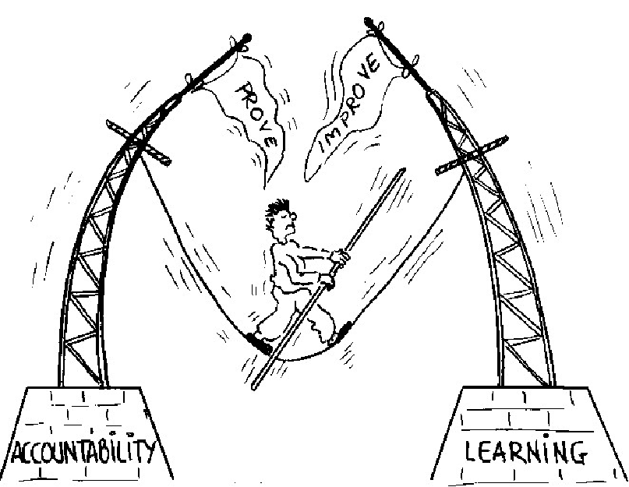
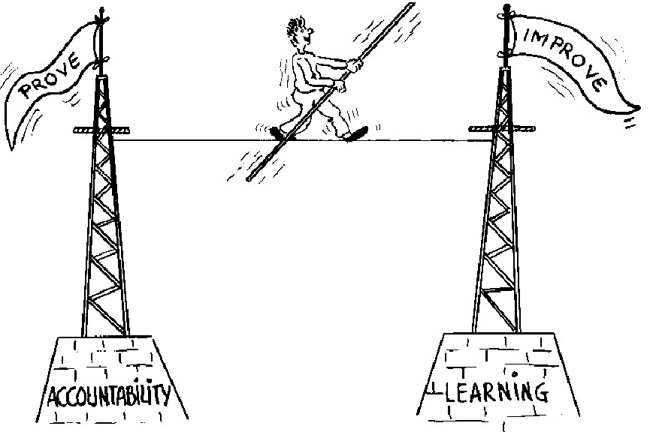

Figure 1: The M&E balancing act (adapted from Earl et al. 2001)
The use of a fusion approach for the PME system for the Centre for Pollination Studies
To achieve this accountability-learning balance, the PME system for the CPS has been derived from a variety of methodologies - the logical framework approach (LFA), which provides the overall structure of the PME system; Outcome Mapping (OM), which promotes the central role of programme partners; and the Action Learning Cycle, which provides the mechanism for the system’s adaptive management approach. The objective of this fusion approach is to provide a framework that will capture lessons learned as a basis for accountability, learning, improvement, sustainability and ultimately impact. Specifically the PME system will comprise of a comprehensive document including an agreed set of monitoring protocols and reporting templates and the activities implemented to operationalise the system.
The objective of the PME system is to provide a framework that will capture lessons learned as a basis for accountability, learning, improvement, sustainability and ultimately impact. Specifically the PME system will comprise of a comprehensive document including an agreed set of monitoring protocols and reporting templates and the activities required to put the system into practice.
Structure of the PME manual
The manual gives some background information about these tools to provide the rationale for the fusion approach adopted and to help orientate those implementing the system. This is followed by four sections on the tools used for monitoring: 1) inputs; 2) activities and outputs; 3) outcomes; and 4) indicators at the objective level. This is followed by a section on how the system will be implemented.
This manual is designed to be a living document that will develop over time to reflect changes in the system.
The principal tools used in the PME System Centre for Pollination Studies
The Logical Framework Approach
The backbone of the system is the Darwin Project logframe which summarises:
• What the project intends to achieve.
• The activities that will be carried out.
• The required resources/inputs (human, technical, infrastructural, etc.).
• The potential problems that could affect the success of the project.
• How the progress and ultimate success of the project will be measured and verified.
The logframe structure is based on the following cause and effect logic - if the inputs are available then certain activities will be carried out. If these activities are carried out, then you can expect certain outputs. It is assumed that the same relationship holds between outputs and purpose, purpose and sub-goal and sub-goal and goal.
The goal statement in all DI projects relates to DI’s core theme - supporting countries rich in biodiversity but poor in financial resources to meet their obligations under one or more of the three major international biodiversity conventions: the Convention on Biological Diversity (CBD); the Convention on International Trade in Endangered Species of Wild Fauna and Flora (CITES); and the Convention on the Conservation of Migratory Species of Wild Animals (CMS). To make the goal operational, it is unpacked into objectives, known as the sub-goal and purpose in DI projects.
Outcome Mapping
The inputs to outputs stages (who is doing what and how at the implementation level) are clear under the project logframe. However, there is little specific information about who will be taking these outputs and converting them to outcomes and ultimately impact. This missing “who” is the partners with whom the CPS interacts directly and enjoys opportunities for influence. These Boundary Partners (BPs) are one of the focuses of Outcome Mapping (OM), a participatory PME approach that, among other things, seeks to ensure that the nature of the link between outputs and outcomes is explicit.
The PME system adopts following OM steps to complement and strengthen the Darwin Project logframe:
Vision: The Vision statement is something that motivates and inspires the participants in the intervention (project or programme). It describes an ideal world that cannot be achieved by the programme alone and is unlikely to be realised during its lifetime.
Mission: The Mission Statement describes how the programme intends to apply its resources in support of the Vision, the areas in which the programme intends to work and how it will support the achievement of outcomes by its Boundary Partners.
Identify and classify stakeholders / identify Boundary Partners: A programme’s sphere of control is usually limited to those who work full-time for the intervention yet its objectives typically relate to large scale changes. An intervention cannot control change; it can only directly influence and contribute to changes in the stakeholders with whom it interacts. OM calls these stakeholders Boundary Partners – those within the intervention’s circle of influence. BPs are defined as: those individuals, groups, and organisations – from civil society, government or business – with whom you interact directly to effect change, anticipate opportunities for change and will engage in mutual learning. There are also other stakeholders, who are still of concern to the intervention but are beyond its direct influence. Some of these stakeholders are likely to be BPs of the intervention’s BPs so it is still possible for the programme to influence those in the circle of concern, albeit indirectly.
Outcome Challenges: Outcome Challenges (OCs) are desired stakeholder outcomes – behavioural changes that support the intervention’s Mission and contribute to its Vision. An OC represents a behavioural change that would occur if the intervention was extremely successful.
Progress markers: Progress Markers (PMs) or Progress Indicators break down the change process by describing changes in actions, activities and relationships leading to the ideal outcome. They articulate the complexity of the change process, can be monitored and observed, and enable on-going assessment of partner’s progress (including unintended results). PMs represent a graduated series of changes from those that should be relatively straightforward (‘expect to see’) to those that are more transformative (‘like to see’) to those that approach an ideal situation (‘love to see’). Expect to see PMs typically relate to the BPs participating in programme activities, e.g. attending training, providing some in-kind co-finance, etc. Like to see PMs could, for example, relate to the provision of cash co-financing for programme activities or placing programme-related issues high on their internal agendas. Love to see PMs relate to the BPs embracing and sustaining the programme-related change, by, for example appointing staff to address the issue of concern and mainstreaming programme-related issues in their strategic plans.
Strategy maps: The Strategy Map is the activity mix that contributes to an Outcome Challenge. Activities can be targeted at the BP (individuals, teams, organisations), or targeted at the environment in which the BP is working.
The incorporation of the OM steps to provide a mechanism to bridge the gap between outputs and outcomes in the Darwin Project Logframe is represented schematically in the figure below.

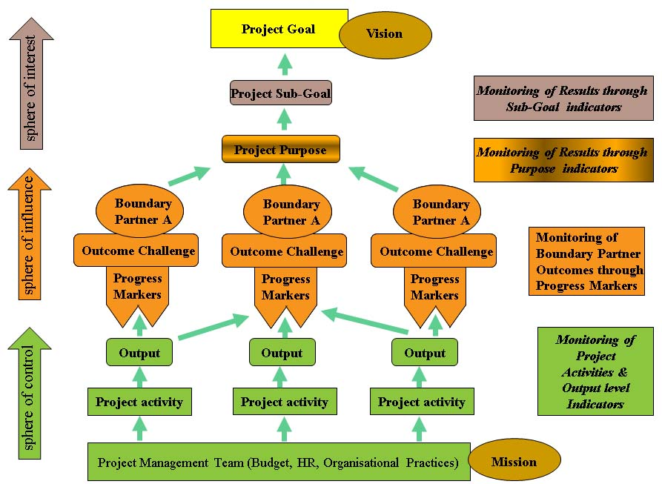
Figure 2: Schematic representation of the Darwin Project logframe incorporating OM steps between outputs and outcomes. The project purpose and sub-goals can be translated into outcome statements.
The Action Learning Cycle
The Action Learning Cycle is a model for learning by doing to encourage evaluative thinking for adaptive management. It consists of a cycle of planning, action, reflection and learning (see Figure 2). Regular PME activities will be undertaken within the framework of the Action Learning Cycle. The Action Learning concepts fit very well with three fundamental PME questions:
- What? What happened – activities, outputs and outcomes
- So what? Why does this matter? What worked well and what lessons were learned?
- Now what? What do we need to do next in order to capitalise on the strengths of what happened and address the lessons learned.
Who k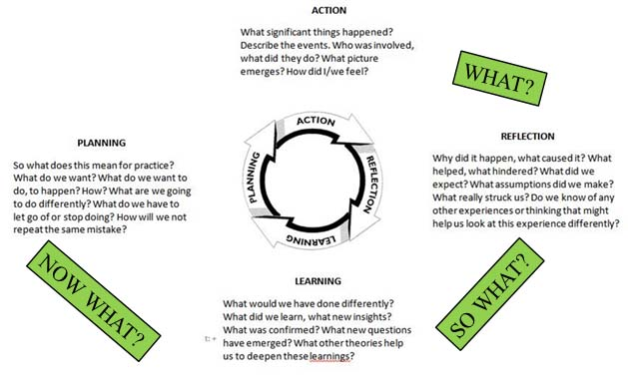
Figure 2: Relationship between a dynamic PME system and the Action Learning Cycle.
Monitoring inputs
Inputs: money, resources and time, are the elements we combine to produce outputs. We need to know what inputs are used to produce what outputs for accountability and in order to gauge our efficiency.
Monitoring money
It is the Project Leader’s (PL) responsibility to ensure that current, complete and accurate financial records for DI funds are maintained. It is the Host Country Coordinator’s (HCC) responsibility to disperse the funds in India and maintain accurate financial records and supply the PL evidence to enable accurate submission of accounts. Daily financial records are kept by logging all expenditure and money received in a spreadsheet (Annex 2.1.). These records are maintained by Parthiba Basu (HCC), supported by Priyadarshini Chakraborti at Calcutta University and returned to Barbara Smith (PL) at GWCT. UK salaries and expenditure are recorded by the PL at GWCT.
Cash advances from the UK Department for Environment, Food and Rural Affairs (Defra) are made quarterly for the first three quarters and for the last quarter in arrears, subject to: i) A satisfactory report on project implementation at 6 months and one year; ii) A satisfactory financial report showing expenditures incurred for the past year, under each project activity; Cash expenditure is recorded in a spreadsheet (Annex 2.1.). Cash and in-kind co-financing are recorded in separate spreadsheet the cofinancing book or journal (Annex 2.2.).
The daily financial records are the basis for a quarterly expenditure statement (Annex 2.3.) in which details of expenditures are reported on an activity by activity basis for the 3 month from 1 April to 30 June, 1 July – 30 September, 1 October – 31 December, and January 1 – 31 March– 31 March. This is submitted by HCC to PL.

All monitoring files are backed up to on the GWCT back-up server. The working files remain on office computers, but in the event of file corruption, fire, etc., the back-up copies will be available. The back-up disks are kept in a separate location from the computer copies.
Monitoring resources
All items of non-expendable equipment bought using Darwin funds are recorded in the inventory of non-expendable equipment (Annex 2.4.). Non-expendable equipment purchased with Darwin funds remains the property of Darwin until the end of the project when they are transferred to the executing agency through a letter of agreement/[equipment] transfer (Annex 2.5.).
Monitoring time
The major tool for monitoring time is the project work plan and timetable (Gantt chart) – a bar chart showing the scheduled and completed work over the period of the project. The Project Workplan and annual plan of action are adjusted as necessary by the PL in consultation with CPS staff. The plan is costed and this forms the basis for the requests for funds from Defra (as described above). The Gantt chart forms the basis for more detailed activity work plans.
Progress on activities over time is monitored through the logframe tracking form, a form documenting progress against the logical framework matrix (Annex 3.1.). It has been developed as a performance management tool for tracking and reporting progress in achieving outputs and outcomes. The logframe indicators are SMART:
Specific
Measurable
Achievable [and Attributable]
Relevant [and Realistic] and
Time-bound [and Timely, Trackable, and Targeted)
Monitoring activities & outputs
Although this manual emphasises monitoring outcomes (ends) this cannot be undertaken in isolation from monitoring activities and outputs (means towards these ends). Activities and outputs are monitored for reasons of accountability, to assess their quality and quantity and the degree to which they contribute to desired and achieved outcomes.
Project Gantt chart and logframe tracking form
These are outlined above.
Monitoring journal
The monitoring journal is designed to keep track of project activities undertaken by the CPS –what happened, who was involved, where did the event take place, what was its significance for the CPS, etc. (Annex 3.2). Each CPS member will maintain their individual monitoring journal which will be consolidated by the PL.
Output tracking forms
Outputs, the products of project activities, are monitored through various output tracking forms. A tracking form for media (documents, posters, flyers, etc., videos, CDs, websites, broadcasts, etc.) is shown in Annex 3.3.; a tracking form for meetings is shown in Annex 3.4.; and a tracking form for meeting participants is shown in Annex 3.5. Other similar forms will be produced and maintained as needs dictate.
Output quality assurance checklists
Output quality assurance checklists are used in order to monitor the quality of the outputs produced. The exact nature of the checklist will depend upon the specific activity. An excerpt from a typical QA checklist template is shown in Annex 3.6.
Output evaluation forms
Certain activities such as training are evaluated by participants upon completion. Evaluation forms are produced on a case by case basis. A typical meeting evaluation form is shown in Annex 3.7.
Monitoring outcomes
The major thrust of the project’s approach to monitoring outcomes is the use of steps taken from Outcome Mapping: Vision (derived from the Darwin Project objectives), Mission, Boundary Partners, Outcome Challenges, Progress Markers and Strategy Maps (derived from project activities). These were formulated at the Core Project Team workshop to develop the outline PME system for the CPS held at the University of Exeter from 7 – 9 November 2012.
Vision
The state and civil society in India will have an increased and shared understanding of the importance of conserving pollinators in Indian agricultural landscapes with a particular focus on supporting the small and marginal farming community engaged in ecologically prudent farming. This will ensure support for the sustainable delivery of pollination and other ecosystem services leading to improved, happy, hopeful and sustainable livelihoods.
Mission
In support of the vision, the CPS will generate and share high quality, credible information about pollinators in Indian agro-ecosystems to increase the knowledge base for ecologically prudent farming in eastern India. The CPS will collaborate with local people and agencies to encourage those working in pilot sites to adopt good farming practices to maintain healthy pollinator populations. The CPS will become financially and institutionally sustainable by developing collaborative initiatives; and intellectually vibrant by producing high impact factor publications. Quality research for the benefit of small and marginal farming communities will help to ensure bright futures for CPS researchers.
Boundary Partners
The following groups were listed as Boundary Partners:
- Research partners | - Media partners
- Tripura University | - All India Radio
- ZSI | - Durdarshan – state level
- Tripura Govt. Agriculture department | - Durdarshan Parliament TV
- Tripura Govt. Biotechnology department | - Private TV Channels S & T Bit (24 Ghanta)
- Orissa Govt. Agriculture department | - Policy partners
- IISER , Trivandrum | - Defra
- ATREE | - DST GoI
- ICAR | - Expansion partners
- Keystone Foundation | - Bees for development
- Dissemination partners | - Practical Action
- Baitarani Trust | - Donors
- OFSDP | - Calcutta University Bioscience departments
- Orissa Govt. Forest department | - Exeter University
- DST, GoI | - GWCT
- AIKS | - CPS Research Staff
- AIPSN  - BES  - Tropical Agriculture Association | - CPS Field Advisors
- The farming community in pilot sites | - Calcutta University Bioscience departments
 | - University of Exeter
 | - GWCT

Outcome Challenges, Progress Markers and Strategy Map
The outcome challenges and progress markers were derived for each group of Boundary Partners. They will be adjusted as the PME plan is rolled out as there was not enough time to consider them in detail when they were being formulated. The adjusted outcome challenges will fulfil SMART criteria. An overall project strategy map has been produced from the project Gantt chart. There is a great deal of overlap so producing a strategy map for each individual Boundary Partner would have resulted in a great deal of repetition.
Partner outcome monitoring form
The progress towards Outcome Challenges will be summarised in a Partner Outcome Monitoring Form (Annex 4.1) which will be completed at a six monthly monitoring meeting.
Logframe tracking form
The logframe Tracking Form – Annex 3.1., (as outlined above) will be used to monitor outcomes as documented in the project logframe (under purpose and sub-goal).
Indicators and means of verification at the Sub-Goal and Purpose levels
Specific project activities (means of verification) will be undertaken to gather measurable indicators relating to the Darwin Project Purpose and Sub-Goal. The relevant sections of the Darwin Project Logframe are reproduced in the table below.
Sub-Goal:  Ensure that native pollination systems in eastern India are well understood in order to facilitate the conservation and improvement of native pollination services and protect the ecosystems on which they depend and benefit the local subsistence farming community | Increased understanding of native pollinator distribution and pollination ecology leads to improved management of pollinators both on farmland and in natural areas.  Improved livelihood conditions of local communities engaged with the CPS. | Pollinator monitoring scheme set-up in Orissa and Tripura together with a network of individuals trained in pollinator monitoring.  Database of base-line information constructed and publicly available; Data analysis investigating the effect of farming on pollination completed and published.  Centre for Pollination Studies established.
Purpose  To improve national and local understanding of the status of native pollinators, their ecology and their management for the benefit of local farming communities and the protection of the agro-ecosystem in partnership with Calcutta University, local government and local civil society organisations. | Provision of information about pollinator distribution.  Improved understanding of native pollinator ecology integrated with information on pollinator-dependent crops’ pollination.  Local people engaged and convinced about need to maintain a healthy pollinator population through conservation of healthy habitat. | Indian field surveyors and advisors established at field centres with the goal of providing advice and education to the local community  Published data analysis revealing status of pollinators, their ecology and impact of farming on them.  Final evaluation survey to establish community attitudes to conservation of pollinators and their habitat.
Implementation of the system
The PL will coordinate the system, using the approaches outlined. This system will be based around the following elements:
- Monitoring of project inputs, activities, outputs and outcomes by the PL (overall responsibility).
- Implementation of the monitoring aspects of specific activities by those responsible for carrying out the activities in question - project leaders, research assistants, PhD and MSc students, advisors and assistants at field sites, etc.
Monitoring will consist of
- Activity-specific monitoring
- Ongoing monitoring
- Periodic monitoring
The PME system is represented schematically in Figure 3.
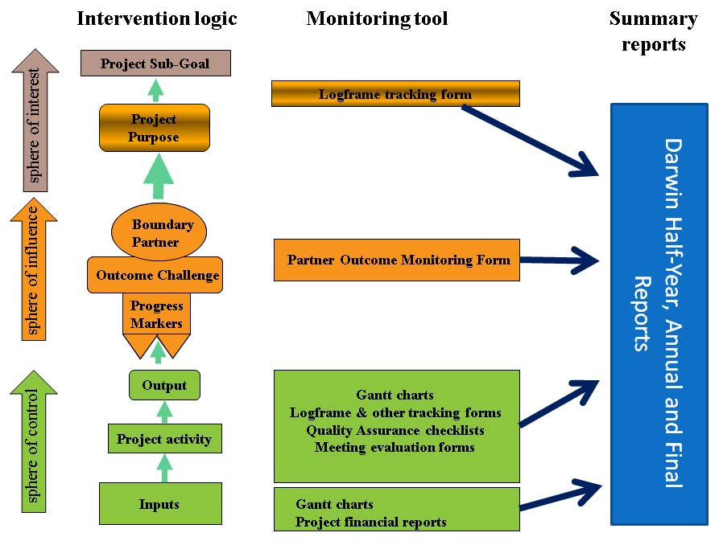
Figure 3: Schematic representation of the PME system for the Centre for Pollination Studies.
This graphic does not include external evaluations
Activity-specific monitoring
All activities will have specific monitoring requirements in terms of accounting for inputs, undertaking activities and producing outputs. The results of certain activities also feed into the Project’s outcome monitoring system. Activity monitoring is the responsibility of those executing the activity under the oversight of the PLs.
Ongoing monitoring
Day to day monitoring is undertaken by those responsible for carrying out the activities in question - project leaders, research assistants, PhD and MSc students, advisors and assistants at field sites, etc. The results of this ongoing monitoring feed into the periodic monitoring.
Periodic monitoring
Periodic monitoring is based on the Darwin Project reporting calendar. The following reports are needed by Darwin:
Half Year Reports – for the six months from 1 April to 31 September: a 1-2 page report (excluding annexes) that outlines: progress over the reporting period; notable issues and their possible effect on the project; details of any expected significant underspend in the budget for the UK financial year (April – March); and any other issues relating to the project or to Darwin’s management, monitoring, or financial procedures.
Annual Reports - for the twelve months from 1 April to 31 March: a report of about 10 pages (excluding annexes) that outlines: project background, location and the basic problem that it seeks to address; partnerships; progress (the main narrative section); monitoring, evaluation and lessons learned; actions taken in response to previous reviews (if applicable); sustainability; dissemination; expenditure; and outstanding achievements of the project during the year (optional). There are two obligatory annexes: report of progress and achievements against the logical framework for the year; and the project’s full current logframe. Further annexes of supplementary material are optional but encouraged as evidence of project achievement.
The Final Report: A report of up to 20 pages (excluding annexes) that is similar in nature but more detailed than the annual report.
Monitoring meetings
CPS representatives will meet with representatives of Boundary Partners at an appropriate frequency to discuss any changes in behaviour, relationships, actions, policies or practices that are linked to CPS activities and outputs. Information from these meetings will feed into CPS monitoring, reflection and learning meetings which will take place at six month intervals, several weeks before the DI reports are due. This will provide the PL with sufficient time to synthesise the information received from these meetings into the format required by Defra.
External evaluation
In order to learn from the experiences of Darwin projects and to be able to report more fully on what the Darwin Initiative has achieved, the Darwin Secretariat commissions the following external independent evaluations of a selection of projects:
- Mid-Term reviews – of current projects with the aim of supporting the project and learning lessons for the Initiative.
- Evaluations of closed projects – these are a mixture of desk based reviews and visits to project locations to seek information on the impact and legacy of Darwin projects.
- Thematic evaluations – focusing on a specific theme and analysing how the Darwin Initiative has contributed to it and what lessons can be learnt from projects which have worked/are working in these areas.
As far as possible the DI Secretariat will inform PLs in advance if their project is chosen. The evaluation reports are not be published or passed to third parties without the PL’s explicit consent. All project reviews are currently passed to Defra and the PL without any identifying details.

INTRODUCTION

People and pollinators – a complex issue
The conservation and management of pollinator populations for sustainable agricultural development in India is a classic example of a complex issue. There are fundamental knowledge gaps and inherent uncertainties associated with both ecological and socio-economic systems. For example, it is difficult to understand, predict and manage the relationships between climate, land management decisions, crop type selection and pollination benefits. The efficient implementation of well-planned project activities in such a system will not always guarantee the intended results.

The M&E balancing act – reconciling accountability and learning
Designing a planning, monitoring and evaluation (PME) system for the CPS is, therefore, a challenge. The PME system must strike a balance between accountability (the degree to which the project executes activities against an approved budget and work plan) and learning (the development of new insights based upon the analysis of project results). This learning can feed into practice through adaptive management - continually improving practices by learning from results). Too much emphasis on accountability may increase the pressure to show everything in a positive light to the detriment of valuable discussions, debate, innovation and adaptation; while an over-flexible system may result in confusion over roles and responsibilities. An effective PME system needs to find a balance between accountability and learning (the need to prove versus the need to improve).

Figure 1: The M&E balancing act (adapted from Earl et al. 2001)

The Centre for Pollination Studies, the Darwin Initiative Project and its objectives
The Centre for Pollination Studies (CPS) has been created within the Calcutta University Department of Modern Biology, to serve as a focal point for pollination ecology and conservation in India. The CPS will be of strategic importance for the University, and will strengthen its position as a key stakeholder in pollination expertise nationally as well as regionally. The centre will focus on applied pollination research and it will maintain an advisory service for subsistence farmers. The flow of information will be two ways, i.e. farmers can feed back their experiences. This will help to refine methodologies and maintain relevance and effectiveness. CPS staff will include advisors, research fellows and assistants at field sites.
The CPS provides the institutional vehicle to sustain and build upon the outcomes of the Darwin Initiative Project - Enhancing the relationship between people and pollinators in Eastern India. The purpose of this three year project ( 1 April 2012 – 31 March 2015) is to improve national and local understanding of the status of native pollinators, their ecology and their management for the benefit of local farming communities and the protection of the agro-ecosystem in partnership with Calcutta University, local government and local civil society organisations. This project purpose is
The following project outputs will contribute to the project purpose:
1. Monitoring framework for pollinators established.
2.a. Base-line information regarding pollinator diversity in the east Indian states of Orissa and Tripura
2.b Assessment of key pollinator species and determination of their ecological requirements.
3. CPS and satellite field centres established. CPS acting as a hub for pollination ecology in Eastern India and the field centres acting as data collection centres and advice and outreach to local farming community.
4. Local engagement and increased capacity among farmers to manage pollinator population.
Further details of what the Darwin Project intends to achieve, and how the progress and ultimate success of the project will be measured and verified, are provided in the project logical framework (Annex 1).
The PME system is referred to as the PME system for the CPS rather than the PME system for the Darwin Project. This is because this system will be used for planning, monitoring and evaluation for the CPS as a whole. The Darwin Project is an essential part of the CPS but the two are not synonymous. The CPS plans to continue after the Darwin Project has closed and to attract funding from a diversity of sources. The CPS is referred to as a programme rather than a project for this reason.

Planning, Monitoring and Evaluation (PME)
Monitoring (ongoing, systematic collection of data to provide management and the main stakeholders of an intervention with indications of the extent of progress and achievement of objectives and progress in the use of allocated funds) is usually seen as the responsibility of those executing or coordinating the programme. Evaluation (periodic systematic data-based assessment to provide useful feedback about the programme for its intended users on stated criteria, e.g. relevance, efficiency, effectiveness, sustainability and impact) is usually regarded as the responsibility of the donor and is carried out by a person or group that is external to the programme.
Monitoring and Evaluation (M&E) is often considered to be a tedious obligation imposed by donors, with its main function being accountability: 1) for money spent against a budget; and 2) for activities executed against a work plan. The link between the Monitoring and the Evaluation in such instances is the fact that programme monitoring information will be the basis for (an external) programme evaluation.
In recent years, however, new approaches have been developed (Patton 2008, Patton 2010) that have emphasised a much closer relationship between monitoring, evaluation and planning to ensure that the results of monitoring are used both for accountability and learning, which feeds back into the planning process. The emphasis of these PME (planning, monitoring and evaluation) approaches is on adaptive management (continually improving practices by learning from results) through the development of evaluative thinking (reflective practice that uses systematically collected data to inform action). In such systems the lines between monitoring and evaluation are more blurred with monitoring results feeding into an internal and ongoing evaluation process. Under such approaches, monitoring is a cross-cutting activity that is the shared responsibility of all those implementing programme activities.
The PME system outlined in this manual adopts such an approach in order to ensure the following: PME is useful to programme stakeholders; rigorous to ensure credibility; participatory to maximise buy-in; and timely to ensure that its findings are incorporated into planning for adaptive management.

Objective of the PME System
The objective of the PME system is to provide a framework that will capture lessons learned from CPS and other related activities as a basis for accountability, learning, improvement, sustainability and ultimately impact. Specifically the PME system will comprise of a comprehensive document including an agreed set of monitoring protocols and reporting templates and the activities required to put the system into practice.

Format and approach of this manual
The CPS’s PME system is designed to maximise programme efficiency (‘are we doing things right’) and effectiveness (‘are we doing the right things’) by using a PME approach derived from the logical framework approach - LFA (Jensen 2012), and using elements of Outcome Mapping – OM (Earl et al 2001) and Action Learning (Barefoot Guide to Learning Practices in Organisations… - Aarnaoudse et al. 2011).
The manual gives some background information about these tools to provide the rationale for the fusion approach adopted and to help orientate those implementing the system. This is followed by four sections on the tools used for monitoring: 1) inputs; 2) activities and outputs; 3) outcomes; and 4) indicators at the objective level. This is followed by a section on how the system will be implemented – reporting formats used, reporting frequencies and roles and responsibilities.
This manual is designed to be a living document that will develop over time to reflect changes in the system.
The document contains three sets of annexes that contain templates for monitoring the following:
- Inputs (Annex 2)
- Activities and outputs (Annex 3)
- Outcomes (Annex 4)

Background: The PME approach used for the CPS
As highlighted above, the CPS is a cross-sectoral, multi-stakeholder intervention operating in a complex environment. Its objective can only be met through the increased capacity of its partners. The project can influence such partner outcomes but it cannot control them.
A PME system that monitors only resources used and activities undertaken (monitoring what you do) is insufficient for a project of this nature. The system also needs to monitor outcomes (monitoring what you achieve). Outcomes are the basis for impact (long-term, sustainable changes in the conditions of people and the state of the environment that structurally reduce poverty, improve human well-being and protect and conserve natural resources) which is ultimately what the project is striving for.
The CPS requires a high level of participation and ownership. The PME system is designed to ensure that the programme does not operate as a stand-alone entity but works with and for its partners. The people and pollinators landscape in India is constituted by these partners, other stakeholders and the interactions among them. This landscape preceded the programme and will remain after the programme is completed. It is therefore, the duty of a programme such as this to do all that it can to ensure that it leaves the people and pollinators landscape in India landscape in a better state than it found it.
The Darwin Project Logframe provides the overall structure of the PME system; Outcome Mapping promotes the central role of project partners; and the Action Learning Cycle provides the mechanism for the system’s adaptive management approach. Each of these approaches is outlined below.

The Logical Framework Approach (LFA)
The logical framework approach (LFA) or logframe is a PME method which uses a standard 4 x 4 matrix to summarise the following:
- What the project intends to achieve.
- The activities that will be carried out.
- The required resources/inputs (human, technical, infrastructural, etc.).
- The potential problems that could affect the success of the project.
- How the progress and ultimate success of the project will be measured and verified.
Table 1: Structure of a logframe matrix
1. Intervention logic | 2. Objectively verifiable indicators | 3. Sources and means of verification | 4. Assumptions
A. Overall objectives/impact (goal)
‘The Greater Why?’
B. Specific objective/outcome (purpose)
‘Why?’
C. Expected results/outputs
‘What’
D. Activities (and processes)  ‘How’ | Means/inputs
The logframe structure is based on the following cause and effect logic - if the inputs are available then certain activities will be carried out. If these activities are carried out, then you can expect certain outputs. It is assumed that the same relationship holds between outputs and purpose, purpose and sub-goal and sub-goal and goal. The LFA’s inputs to impacts logic is summarised in the figure below
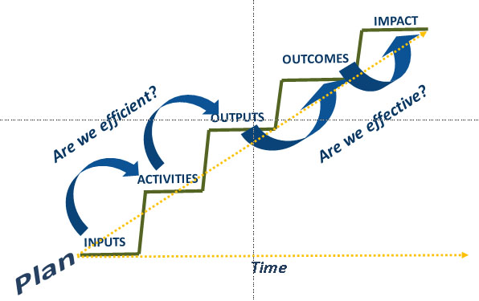
Figure 2: The proposed logical flow from inputs to impacts under the LFA
(from Ricardo Wilson-Grau, inspired by Jeff Conklin, cognexus.org)
The goal statement in all DI projects relates to DI’s core theme - supporting countries rich in biodiversity but poor in financial resources to meet their obligations under one or more of the three major international biodiversity conventions: the Convention on Biological Diversity (CBD); the Convention on International Trade in Endangered Species of Wild Fauna and Flora (CITES); and the Convention on the Conservation of Migratory Species of Wild Animals (CMS). To become operational the goal is unpacked into objectives, known as the sub-goal and purpose in DI projects.
The goal section of the logframe does not include measurable indicators, means of verification or important assumption as there are many non-project actors and factors that also contribute towards positive impacts on biodiversity and positive biodiversity impacts mostly occur beyond the life of a project.
The sub-goal (or overall objective) is an objective which contributes to the goal. The sub-goal section of the logframe includes measurable indicators and means of verification but not important assumptions. Assumptions are external conditions which must be met if planned activities are to result in outputs, outputs are to result in outcomes, and outcomes are to report in impacts. It makes no sense to have assumptions at the sub-goal level when the link between the sub-goal and goal is not being monitored.
The purpose is a more specific objective that unpacks the sub-goal. Measurable indicators, means of verification and important assumptions are included at the purpose level because the link between the purpose and sub-goal is monitored.
The Darwin Project logframe is represented schematically in the figure below:
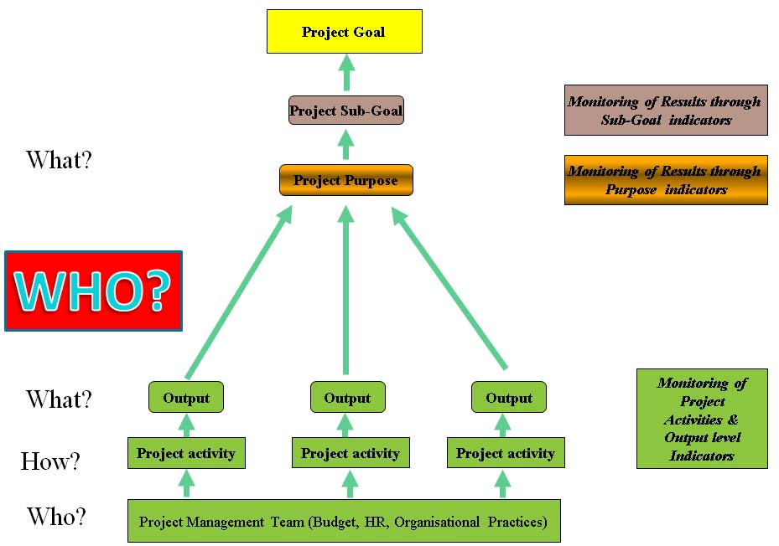
Figure 3: Schematic representation of the Darwin Project logframe illustrating the ‘logic gap’ between outputs and outcomes. The project purpose and sub-goals can be translated into outcome statements.

Outcome Mapping (OM)
The inputs to outputs stages (who is doing what and how at the project implementation level) are very clear under the project logframe. However, there is no specification of who will be taking these outputs and converting them to outcomes and ultimately impact. This missing “who” is the partners with whom the project interacts directly and enjoys opportunities for influence. These Boundary Partners (BPs) are one of the principal focuses of Outcome Mapping (OM), a participatory PME approach that, among other things, seeks to ensure that the nature of the link between outputs and outcomes is explicit.
OM can be used as a stand-alone PME method or in combination with other approaches, as we are doing in the CPS PME system. The “by the book version” of OM comprises of three stages: 1) Planning (‘Intentional design’); 2) Monitoring (‘Outcome and Performance Monitoring’); and 3) Evaluation Planning. Twelve steps are nested within the three stages. We did not include Evaluation Planning in our system as not all Darwin projects are externally evaluated (see Section 5.4.). This type of process will be undertaken prior to mid-term, final or thematic evaluations if the People and Pollinators Project is selected. We focused on the Planning and Monitoring stages to provide the bridge between the outputs and outcomes levels of the logframe. To do this we used the following steps:
Planning (intentional design)
- Vision (your dream)
- Mission (your contribution to the achievement of the Vision)
- Define desired results (outcomes)
  - Identify and classify stakeholders / identify Boundary Partners
  - Define Boundary Partner Outcomes (Outcome Challenges)
  - Define Indicators to assess whether we are on track towards our outcomes (Progress Markers)
- Define the strategy (the activity mix) that will contribute to the Outcome Challenges (Strategy Maps)
Monitoring
This is covered throughout the PME manual.
The OM steps used in the CPS PME system are explained in more detail below:
Vision
The Programme Vision statement is something that motivates and inspires the programme participants. It describes an ideal world that cannot be achieved by the programme alone and is unlikely to be realised in the programme’s lifetime. It functions as a lighthouse – something to guide; and a star – something big to reach for. The vision is situated somewhere between the goal and sub-goal in the logframe. One of the most inspirational examples of a vision(ary) statement is the “dream” speech delivered by Martin Luther King on August 28 1964.
Mission
The Programme Mission Statement describes how the programme intends to apply its resources in support of the Vision, the areas in which the programme intends to work and how it will support the achievement of outcomes by its Boundary Partners.
Identify and classify stakeholders / identify Boundary Partners
A programme’s sphere of control is usually limited to those who work full-time for the programme yet its objectives typically relate to large scale changes. A programme cannot control change; it can only directly influence and contribute to changes in those with whom it interacts. OM calls these stakeholders Boundary Partners – those within the programme’s sphere of influence. BPs are defined as: those individuals, groups, and organisations – from civil society, government or business – with whom you interact directly to effect change, anticipate opportunities for change and will engage in mutual learning. There are also other stakeholders, who are still of interest/concern to the programme but are beyond its direct influence. Some of these stakeholders are likely to be BPs of the programme’s BPs so it is still possible for the project to influence those in the sphere of interest/concern, albeit indirectly. This model is illustrated in the figure below.
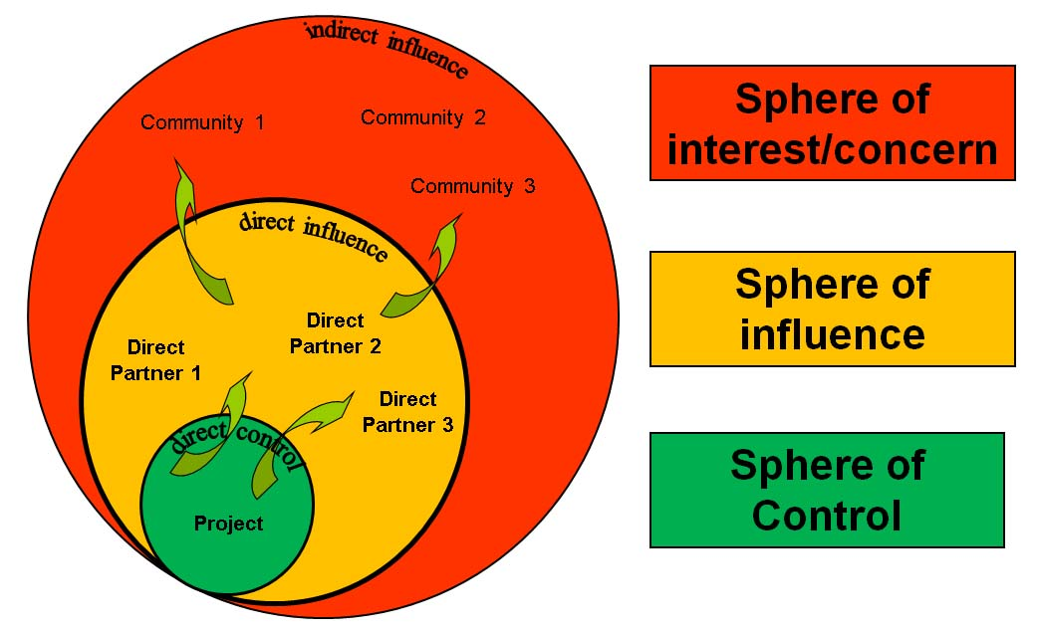
Figure 4: Representation of the relationship between a project’s spheres of control, influence and interest/concern

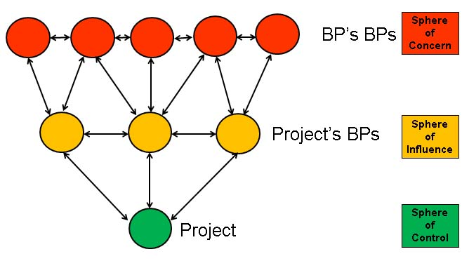
Figure 5: Boundary Partners also have Boundary Partners
Outcome Challenges
Outcome challenges (OCs) are desired stakeholder outcomes – behavioural changes that support the Project’s Mission and contribute to its Vision. An OC represents a behavioural change that would occur if the project was extremely successful.
Progress markers
Progress Markers (PMs) or Progress Indicators break down the change process by describing changes in actions, activities and relationships leading to the ideal outcome. They articulate the complexity of the change process, can be monitored and observed, and enable on-going assessment of partner’s progress (including unintended results). PMs represent a graduated series of changes from those that should be relatively straightforward (‘expect to see’) to those that are more transformative (‘like to see’) to those that approach an ideal situation (‘love to see’). Expect to see PMs typically relate to the BPs participating in programme activities, e.g. attending training, providing some in-kind co-finance, etc. Like to see PMs could, for example, relate to the provision of cash co-financing for programme activities or placing programme-related issues high on their internal agendas. Love to see PMs relate to the BPs embracing and sustaining the programme-related change, by, for example appointing staff to address the issue of concern and mainstreaming programme-related issues in their strategic plans. The differences between these PM levels are illustrated in the figure below.
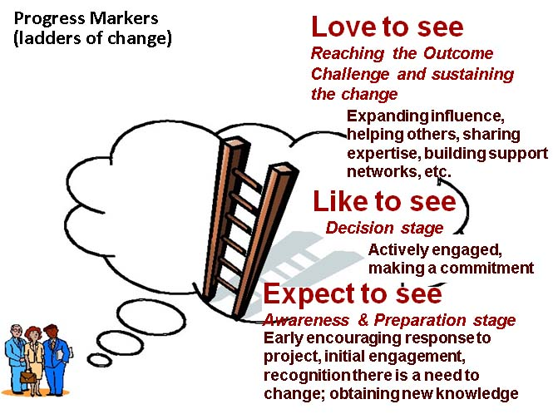
Figure 6: Progress markers and the process of behavioural change
Strategy maps
The Strategy Map is the activity mix that contributes to an Outcome Challenge. Activities can be targeted at the BP (individuals, teams, organisations), or targeted at the environment in which the BP is working. The OM manual (Earl et al 2001) identifies six interlinked kinds of strategies (summarised graphically below).
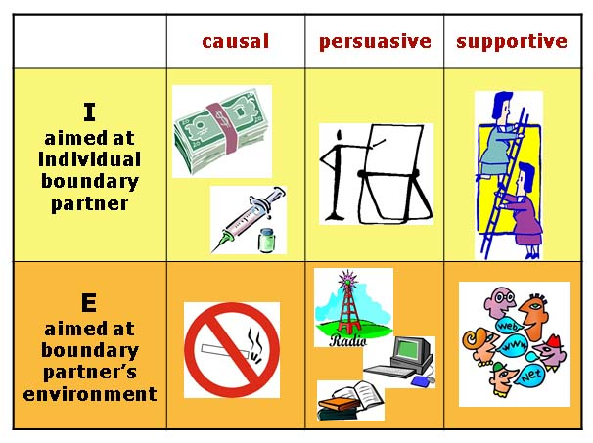
Figure 7: Six interlinked types of strategy (activity mixes).
At the level of the individual or specific group: causal strategies are those that produce a direct output, e.g. providing money, obtaining a research grant or preparing a report; persuasive strategies are one-off activities that arouse new thinking or skills, e.g. training, skill enhancement and the production of manuals; and supportive strategies are longer term nurturing activities, e.g. a project team member who provides regular guidance and input such as management or fundraising support.
At the level of the individual’s or group’s environment: causal strategies are those that change the physical or policy environment, e.g. improved Internet access, updated policies and laws and terms of reference; persuasive strategies disseminate information/messages to a broad audience, e.g. radio broadcasts, publications and conferences; and supportive strategies create learning/action networks such as research networks or joint work programmes.
The incorporation of the OM steps to provide a mechanism to bridge the gap between outputs and outcomes in the Darwin Project Logframe is represented schematically in the figure below.

Figure 8: Schematic representation of the Darwin Project logframe incorporating OM steps between outputs and outcomes. The project purpose and sub-goals can be translated into outcome statements.

Action Learning – putting the P in PME
The Action Learning Cycle is a model for learning by doing to encourage evaluative thinking for adaptive management. It consists of a cycle of planning, action, reflection and learning (see Figure 8). Regular PME activities will be undertaken within the framework of the Action Learning Cycle. The Action Learning concepts fit very well with three fundamental PME questions:

- What? What happened – activities, outputs and outcomes
- So what? Why does this matter? What worked well and what lessons were learned?
- Now what? What do we need to do next in order to capitalise on the strengths of what happened and address the lessons learned.
Figure 9: Relationship between a dynamic PME system and the Action Learning Cycle.

MONITORING INPUTS

Introduction
Inputs: money, resources and time, are the elements we combine to produce outputs. We need to know what inputs are used to produce what outputs for accountability and in order to gauge our efficiency.

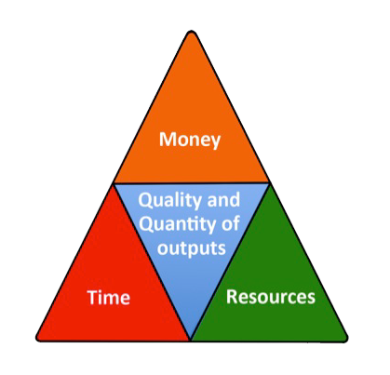

Figure 10: Inputs – money, resources (including people) and time which are used to produce outputs
Graphic from inProgress 2012

Monitoring money
It is the Project Leader’s (PL) responsibility to ensure that current, complete and accurate financial records for DI funds are maintained. It is the Host Country Coordinator’s (HCC) responsibility to disperse the funds in India and maintain accurate financial records and supply the PL evidence to enable accurate submission of accounts. UK salaries and expenditure are recorded by the PL at GWCT.

Daily financial records
Daily financial records are kept by logging all expenditure and money received in a spreadsheet (Annex 2.1.). These records are maintained by Parthiba Basu (HCC), supported by Priyadarshini Chakraborti at Calcutta University and returned to Barbara Smith (PL) at GWCT.

Financial reporting
The daily financial records are the basis for a quarterly expenditure statement (Annex 2.2.) in which details of expenditures are reported on an activity by activity basis for the 3 month from 1 April to 30 June, 1 July – 30 September, 1 October – 31 December, and January 1 – 31 March– 31 March. This is submitted by HCC to PL.

Cash advances
Cash advances from the UK Department for Environment, Food and Rural Affairs (Defra) are made quarterly for the first three quarters and for the last quarter in arrears, subject to: i) A satisfactory report on project implementation at 6 months and one year; ii) A satisfactory financial report showing expenditures incurred for the past year, under each project activity.

Co-financing
Cash expenditure is recorded in a spreadsheet – the daily cash book (Annex 2.1.). Cash and in-kind co-financing are recorded in separate spreadsheet – the cofinancing book or journal (Annex 2.2.).
File Retention
All monitoring files are backed up to on the GWCT back-up server. The working files remain on office computers, but in the event of file corruption, fire, etc., the back-up copies will be available. The back-up disks are kept in a separate location from the computer copies.

Monitoring resources
All items of non-expendable equipment bought using Darwin funds are recorded in the inventory of non-expendable equipment (Annex 2.4.). Non-expendable equipment purchased with Darwin funds remains the property of Darwin until the end of the project when they are transferred to the executing agency through a letter of agreement/[equipment] transfer (Annex 2.5.).

Monitoring time
The major tool for monitoring time is the project work plan and timetable (Gantt chart) – a bar chart showing the scheduled and completed work over the period of the project. The Project Workplan and annual plan of action are adjusted as necessary by the PL in consultation with CPS staff. The plan is costed and this forms the basis for the requests for funds from Defra (as described above). The Gantt chart forms the basis for more detailed activity work plans.
The Gantt chart forms the basis for more detailed activity work plans.
Progress on activities over time is monitored through the logframe tracking form (see Section 2 and Annex 3.1.).

MONITORING ACTIVITIES & OUTPUTS

Introduction
Although this manual emphasises monitoring outcomes (ends) this cannot be undertaken in isolation from monitoring activities and outputs (means towards these ends). Activities and outputs are monitored for reasons of accountability, to assess their quality and quantity and the degree to which they contribute to desired and achieved outcomes.

Monitoring activities & outputs

Project Gantt chart and logframe tracking form
As mentioned above, activities are monitored against the project Gantt chart (Annex 2.6). Specifically, this is done through the logframe tracking form (Annex 3.1), a form documenting progress against the logical framework matrix (Annex 1). It has been developed as a performance management tool for tracking and reporting progress in achieving outputs and outcomes.
The logframe indicators are SMART:
1. Specific: The indicators capture the essence of the desired result by clearly and directly relating to achieving an objective, and only that objective.
2. Measurable: The monitoring system and its indicators are unambiguously specified so that all parties agree on what the system covers and there are practical ways to measure the indicators and results.
3. Achievable and Attributable: The system identifies what changes are anticipated as a result of the intervention and whether the result(s) are realistic. Attribution requires that changes in the targeted developmental issue can be linked to the intervention.
4. Relevant and Realistic: The system establishes levels of performance that are likely to be achieved in a practical manner, and that reflect the expectations of stakeholders.
5. Time-bound, Timely, Trackable, and Targeted: The system allows progress to be tracked in a cost-effective manner at desired frequency for a set period, with clear identification of the particular stakeholder group to be impacted by the project or program.
The logframe tracking form consists of four columns that correspond to those in the logframe – objectives, objectively measurable indicators, means of verification and important assumptions. There are additional columns for ‘group’ – those undertaking the activity, ‘responsibility’ – those who are responsible for managing the activity and who oversee the monitoring of the activity, ‘timeframe’ – the time within which the execution of the activity was planned and achievement status at six-monthly intervals. This column will reflect the changes in indicator values in relation to project implementation progress on a half-yearly basis to coincide with the preparation of the Darwin progress reports.

Monitoring journal
The monitoring journal is designed to keep track of project activities undertaken by the CPS –what happened, who was involved, where did the event take place, what was its significance for the CPS, etc. (Annex 3.2). Each CPS member will maintain their individual monitoring journal which will be consolidated by the PL.

Output tracking form
Outputs, the products of project activities, are monitored through various output tracking forms. A tracking form for media (documents, posters, flyers, etc., videos, CDs, websites, broadcasts, etc.) is shown in Annex 3.3.; a tracking form for meetings is shown in Annex 3.4.; and a tracking form for meeting participants is shown in Annex 3.5. Other similar forms will be produced and maintained as needs dictate.

Output quality assurance checklists
Output quality assurance checklists are used in order to monitor the quality of the outputs produced. The exact nature of the checklist will depend upon the specific activity. An excerpt from a typical QA checklist template is shown in Annex 3.6.

Output evaluation forms
Certain activities such as training are evaluated by participants upon completion. Evaluation forms are produced on a case by case basis. Typically the following should be assessed for a training activity: the degree to which the activity achieved its stated objective; the clarity of the training agenda, the clarity of the presentations given, the quality of the resources provided, the quality of logistical support, and suggested next steps. A typical meeting evaluation form is shown in Annex 3.7.

MONITORING OUTCOMES

Introduction
As was discussed, the major thrust of the project’s approach to monitoring outcomes is the use of steps taken from Outcome Mapping: Vision (derived from the project sub-goal and purpose), Mission, Boundary Partners, Outcome Challenges, Progress Markers and Strategy Maps (derived from project activities). The information summarised in this section represents the consolidation of the results of the Core Project Team workshop to develop the outline PME system for the CPS held at Exeter University from 7 – 9 November 2012.

Project Vision
VISION: The state and civil society in India will have an increased and shared understanding of the importance of conserving pollinators in Indian agricultural landscapes with a particular focus on supporting the small and marginal farming community engaged in ecologically prudent farming. This will ensure support for the sustainable delivery of pollination and other ecosystem services leading to improved, happy, hopeful and sustainable livelihoods.

Project Mission
MISSION: In support of the vision, the CPS will generate and share high quality, credible information about pollinators in Indian agro-ecosystems to increase the knowledge base for ecologically prudent farming. The CPS will collaborate with local people and agencies to encourage those working in pilot sites to adopt good farming practices to maintain healthy pollinator populations. The CPS will become financially and institutionally sustainable by developing collaborative initiatives; and intellectually vibrant by producing high impact factor publications. Quality research for the benefit of small and marginal farming communities will help to ensure bright futures for CPS researchers.

Boundary Partners
Those identified in the workshop as falling in the spheres of control, influence and interest are shown in the figure below.
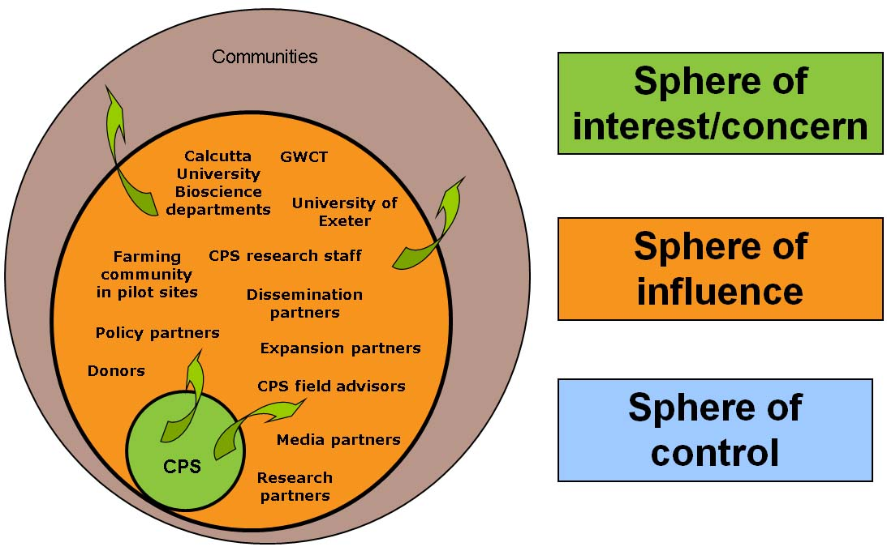
Figure 11: Spheres of control, influence and interest of the CPS.
This exercise was the basis for the following Boundary Partner list:
- Research partners | - Media partners
- Tripura University | - All India Radio
- ZSI | - Durdarshan – state level
- Tripura Govt. Agriculture department | - Durdarshan Parliament TV
- Tripura Govt. Biotechnology department | - Private TV Channels S & T Bit (24 Ghanta)
- Orissa Govt. Agriculture department | - Policy partners
- IISER , Trivandrum | - Defra
- ATREE | - DST GoI
- ICAR | - Expansion partners
- Keystone Foundation | - Bees for development
- Dissemination partners | - Practical Action
- Baitarani Trust | - Donors
- OFSDP | - Calcutta University Bioscience departments
- Orissa Govt. Forest department | - Exeter University
- DST, GoI | - GWCT
- AIKS | - CPS research staff
- AIPSN BES  - Tropical Agriculture Association | - CPS field advisors
- The farming community in pilot sites | - Calcutta University Bioscience departments
 | - University of Exeter
 | - GWCT
Some of those groups in the BP list can be termed "internal BPs" (e.g. CPS research staff and CPS rural advisors). As part of CPS, they are helping to contribute to BP change. However, they also have a professional life beyond the CPS. Therefore, the OCs and PMs of this group relate to areas that the CPS can influence directly but not control.

Outcome Challenges and Progress Markers
Outcome challenges and progress markers are presented for each BP group. They will be adjusted as the PME plan is rolled out because they were formulated by a small group with minimal input from BP representatives. An overall project strategy map has been produced from the project logframe. Individual strategy maps for each Boundary Partner would have resulted in a great deal of repetition as many activities are relevant to several BPs.
The adjusted outcome challenges will fulfil the following SMART criteria (Wilson-Grau pers. comm.):
Specific: The outcome is formulated in sufficient detail so that the systems primary intended user without specialised subject or contextual knowledge will be able to understand and appreciate what changed. Who changed what, when and where?
Measurable: The description of the outcome provides objective, verifiable quantitative and qualitative information, independent of who is collecting data. How much? How many? When and where did the change happen?
Achieved (by you while not necessarily attributable to you): There is a plausible relationship, a logical link between the outcome and what you did that contributed to it. Who did what that wholly but probably partially, indirectly or indirectly, intentionally or unexpectedly contributed?
Relevant: The outcome represents a significant step towards the impact that you seek.
Timely: The outcome occurred within the time period being monitored or evaluated, although your contribution may have been months or even years before.
The person(s) who identify and formulate the outcome and your contribution must be well placed to assess both. They should have a special position or experience that gives them the requisite knowledge to describe the outcome and how you contributed. Thus, what may be seen as 'anecdotal' becomes critical data because of the informant(s)’s value.
Expect to see progress markers should be all be achieved by project mid-term. Like to see progress markers should be achieved by the end of the project and love to see progress markers will be achieved by the end of the project if this BP is extremely successful.

Research Partners
Outcome Challenge
The CPS intends to see research partners who are:
- Collaborating with CPS in developing and implementing new research projects; and
- Jointly organising national/international symposia/training with CPS.
Expect to see: Research partners are:
- Willing to meet with CPS and discuss the development and implementation of joint research projects.
Like to see: Research partners are:
- Developing research projects with CPS.
- Sharing their insights with CPS in a transparent way.
- Jointly organising trainings with CPS.
Love to see: Research partners are:
- Approaching CPS for advice and collaboration.
- Implementing funded research projects with CPS.

Dissemination Partners
Outcome Challenge
The CPS intends to see dissemination partners disseminate credible knowledge and good practice in pollinator conservation among farmers and field practitioners beyond the reach of the CPS through the organisation of farmer festivals, road shows, farmer training and offering advice/advisory services. Dissemination partners will also disseminate relevant material to and engage with policy makers at advocacy meetings and lobbying events.
Expect to see: Dissemination partners:
- Are willing to meet with CPS and discuss the role and importance of pollinators in agro-ecosystems.
- Demonstrate an understanding of the role and importance of pollinators in agro-ecosystems.
Like to see: Dissemination partners:
- Participate in events organised by CPS.
Love to see: Dissemination partners:
- Actively promote the role and importance of pollinators in agro-ecosystems by disseminating CPS approaches, outputs and outcomes (e.g. training, promotional materials and research findings) to other communities and stakeholder groups beyond the reach of CPS.

The farming community in pilot sites
Outcome Challenge
The CPS intends to see the farming community in pilot sites engage with the CPS to co-create sustainable pollinator practices that are they are motivated to promote within and beyond pilot sites.
Expect to see: The farming community in pilot sites:
- Are willing to meet with CPS to discuss actively participating in events organised by CPS.
- Actively share information with CPS staff in events organised by CPS.
- Appreciates the importance of pollinators and their conservation.
Like to see: The farming community in pilot sites:
- Approach CPS staff for advice outside events organised by CPS
- Approach CPS staff to share their experience outside events organised by CPS.
- Adopt pollinator-friendly farming practices including but not limited to beekeeping.
Love to see: The farming community in pilot sites:
- Champion pollinator-friendly farming practices within pilot sites and promote them to neighbouring communities.

Media partners
Outcome Challenge
The CPS intends to see media partners providing media platforms to CPS for disseminating knowledge and practices by means of news stories, short documentaries on CPS research and partner events.
Expect to see: Media partners:
- Are willing to meet with CPS and discuss the provision of media platforms to the CPS for disseminating information on the role and importance of pollinators in agro-ecosystems.
Like to see: Media partners:
- Cover CPS events in their media platforms.
- Disseminate key messages that CPS seeks to disseminate.
Love to see: Media partners:
- Approach CPS for expert opinion when pollinators are in the news.
- Develop regular and larger media engagements that involve CPS.

Policy partners
Outcome Challenge
The CPS intends to see policy partners working in conjunction with CPS in developing evidence-based policies on the conservation of pollinators in agro-ecosystems.
Expect to see: Policy partners:
- Are aware of the existence of CPS.
- Are aware of the activities of CPS.
Like to see: Policy partners:
- Agree to engage with CPS to discuss the developing evidence-based policies on the conservation of pollinators in agro-ecosystems.
Love to see: Policy partners:
- Seek CPS’s opinion on relevant policy areas.

Expansion partners
Outcome Challenge
The CPS intends to see expansion partners collaborating with CPS to expand CPS activities within India and into other countries in the South Asian region.
Expect to see: Expansion partners:
- Attend project-related events.
- Are willing to meet with CPS to discuss the development of CPS projects and programmes in India and other SAARC countries.
Like to see: Expansion partners:
- Developing projects with CPS.
- Sharing their insights with CPS in a transparent way.
- Jointly organising meetings/symposia with CPS.
Love to see: Expansion partners:
- Implementing funded research projects with CPS.
- Approaching CPS for advice and collaboration.

Donors
Outcome Challenge
The CPS intends to see a diverse range of donors contributing to CPS’s activities to ensure financial sustainability of CPS.
Expect to see: Donors:
- Attend project-related events.
- Are willing to meet project partners to discuss the development of CPS projects and programmes.
Like to see: Donors:
- Donors invite funding proposals CPS.
Love to see: Donors:
- Donors invite funding proposals from CPS.

CPS research staff
Outcome Challenge
The CPS intends to see CPS research staff produce research that is publishable and useful and promotes the work of the CPS and the career prospects of CPS staff.
Expect to see: CPS research staff:
- Continue to work for CPS for the duration of the Darwin Project – at least an 80% maintenance rate.
- Publish at least three papers in peer reviewed journals by the close of the Darwin Project.
- Present their research findings in national and international conferences.
Like to see: CPS research staff:
- Publish at least six papers in peer reviewed journals by the close of the Darwin Project.
- Present their research findings on national radio and television.
Love to see: CPS research staff:
- Submit PhD theses within the period of the Darwin Project.

CPS rural advisors
Outcome Challenge
The CPS intends to see CPS field advisors establish and maintain a link between CPS researchers and key stakeholders on the ground such as farmers and farm practice and local policy makers and government departments to support pollinator conservation for sustainable farming.
Expect to see: Rural advisors:
- Building and maintaining a network of farmer contacts
- Arranging and overseeing farmer training and farmer festivals
- Managing and supporting Field Assistants
- Maintaining links with CPS.
Like to see: Rural advisors:
- Taking the initiative to develop new ways of building sustainable relationships with farmers
- Engaging local policy makers and government departments in the work done at the CPS.
Love to see: Rural advisors:
- Establishing a permanent rural advice centre and service.

Calcutta University Bioscience departments
Outcome Challenge
The CPS intends to see Calcutta University Bioscience departments highlight the work of the CPS by disseminating CPS outputs and promote its sustainability and expansion by providing in-kind support, submitting funding applications and promoting the CPS model to other regions and countries.
Expect to see: Calcutta University Bioscience departments:
- Disseminating the outputs of the CPS.
- Promoting the CPS through press releases.
- Providing in-kind support for the CPS for the duration of the Darwin Project.
Like to see: Calcutta University Bioscience departments:
- Supporting the continuation of the CPS by submitting collaborative funding applications.
Love to see: Calcutta University Bioscience departments:
- Providing in-kind support for the CPS beyond the duration of the Darwin Project.
- Promoting the CPS as a model to be extended to other regions / countries.

University of Exeter
Outcome Challenge
The CPS intends to see University of Exeter highlight the work of the CPS by disseminating CPS outputs and promote its sustainability and expansion by submitting funding applications and promoting the CPS model to other regions and countries.
Expect to see: University of Exeter:
- Disseminating the outputs of the CPS.
- Promoting the project through press releases.
- Providing in-kind support for the CPS for the duration of the Darwin Project.
Like to see: University of Exeter:
- Supporting the continuation of the CPS by submitting collaborative funding applications.
Love to see: University of Exeter:
- Exchanging advice with CPS and seeking to extend the approach to other regions / countries.

GWCT
The CPS intends to see GWCT highlight the work of the CPS by disseminating CPS outputs and promote its sustainability and expansion by submitting funding applications and promoting the CPS model to other regions and countries.
Expect to see: GWCT:
- Disseminating the outputs of the CPS via Gamewise and the Annual Review.
- Promoting the CPS through press releases.
Like to see: GWCT:
- Supporting the continuation of the CPS by submitting collaborative funding applications.
Love to see: GWCT:
- Exchanging advice with CPS and seeking to extend the approach to other regions / countries.

Strategy Map
As mentioned in the previous section, a single strategy map has been produced from the project Gantt chart (in the table below). The BPs will be asked which activities are relevant to them at the next project monitoring meeting. It may then be useful to produce strategy maps for each BP.
Table 2: Overall strategy map for the CPS
Strategies aimed at the Boundary Partner or group of Boundary Partners
Causal | Persuasive | Supportive
1.1.a. Project start-up , capital items purchased | 2.1.) MSc students trained in taxonomy and research techniques | 1.2.a. Partner meetings in host country
1.1.a. Project start-up , capital items purchased | 2.2.a. Farmers trained in pollinator survey and recording (12 per year) | 1.2.a. Partner meetings in host country
1.1.a. Project start-up , capital items purchased | 2.2.b. In years 2 and 3 farmers from the previous year will help with training | 1.2.b. Partner meetings in UK
1.1.b. 1 Post-doc Project manager, 2 Research fellows, 4 Field assistants appointed | 2.3.) Research fellows trained and CPS staff trained in long-term monitoring methods and data management | 5.2.c. Advisor engaging with farming community
 | 2.4.) CPS training: Taxonomy, experimental pollination ecology | 7.1.) Annual ‘celebration’ at each field site (6 per year)
 | 2.5.) Workshops for children | 7.1.) Annual ‘celebration’ at each field site (6 per year)
1.1.c. 2 advisors appointed | 3.1.a. Long-term monitoring strategy devised and plots/transects identified | 7.2.a. Feedback sessions with farmers
1.1.c. 2 advisors appointed | 3.1.b. Permanent gourd plots set-up | 7.2.a. Feedback sessions with farmers
1.1.d. Field stations set - up. Advisor accommodation secured (outside project timeframe but if go-ahead given some early preparation will take place) | 3.2.a. Field surveys on farm and in surrounding area | 7.2.b. Farmer visit to CPS
 | 3.2.b. Pollinator visitors to permanent gourd plots recorded
 | 3.2.c. Gourd yield recorded
 | 4.1.) Research questions refined
 | 4.2.a. Experimental work initiated
 | 4.2.b. Pollination ecology experimental work
5.1.a. Advisor in place | 4.2.c. Testing beehive utility at CPS
8.1.) Quarterly teleconference between research partners | 4.2.d. Testing beehive utility in the field
8.1.) Quarterly teleconference between research partners | 4.2.e. Testing native floral strips to benefit pollinators (at CPS)
8.1.) Quarterly teleconference between research partners | 4.2.f. Testing native floral strips to benefit pollinators (in the field)
8.1.) Quarterly teleconference between research partners | 5.2.b. Advisor attending all training courses
 | 6.1.) Data-base for long term data established
 | 6.2.) Data-base for research projects established
 | 6.4.) Data analysis
 | 9.1.a.Integration and final analysis of all survey data
 | 9.1.b. Completion of specimen databases
 | 9.1.c. Publication of project results on webpages
Strategies aimed at the Environment of the Boundary Partner or group of Boundary Partners
Causal | Persuasive | Supportive
 | 6.3.) Data-base of long-term data made public | 9.2.b. Conferences attended
 | 9.1.a. Press releases | 9.2.b. Conferences attended
 | 9.1.b. Newspaper articles
 | 9.2.a. Scientific publications submitted
 | 9.2.b. Conferences attended
 | 9.1.f. writing of conservation assessments and recommendations

Partner outcome monitoring form
The progress towards Outcome Challenges will be summarised in a Partner Outcome Monitoring Form (Annex 4.1) which will be completed at the CPS’s six monthly monitoring meeting (see Section 4.4).

Logframe tracking form
The logframe Tracking Form – Annex 3.1., (as outlined in Section 2) will be used to monitor outcomes as documented in the project logframe (under purpose and sub-goal).

IMPLEMENTATION OF THE SYSTEM
The implementation arrangements for the PME system are outlined in this section. The PL will coordinate a system, using the approaches outlined. This system will be based around the following elements:
- Monitoring of project inputs, activities, outputs and outcomes by the PLs (overall responsibility).
- Implementation of the monitoring aspects of specific activities by those responsible for their execution e.g. project leaders, research assistants, PhD and MSc students, advisors and assistants at field sites, etc.
Monitoring will consist of activity-specific monitoring, ongoing monitoring and periodic monitoring.

Activity-specific monitoring
All activities will have specific monitoring requirements in terms of accounting for inputs, undertaking activities and producing outputs. Activity monitoring is the responsibility of those executing the activity under the oversight of the under the oversight of the PL and the HCC.

Ongoing monitoring
Day to day monitoring is undertaken by those responsible for carrying out the activities in question - project leaders, research assistants, PhD and MSc students, advisors and assistants at field sites, etc. The results of this ongoing monitoring feed into the periodic monitoring.

Periodic monitoring
Periodic monitoring is based on the Darwin Project reporting calendar. The following reports are needed by Darwin:
Half Year Reports – for the six months from 1 April to 31 September. These reports consist of: an outline of progress over the reporting period against the agreed timetable for the project; details of any notable problems / unexpected developments, the impact these could have on the project and whether the changes will affect the budget and timetable of project activities; details of any expected significant (e.g. more than £5,000) underspend in the budget for the UK financial year (1 April – 31 March); any other issues relating to the project or to Darwin’s management, monitoring, or financial procedures. The report should be between 1-2 pages maximum and must be submitted to Defra by 31 October. These reports are responsibility of the PL. The Half Year Report format is available on the Resources for projects page of the Darwin Initiative website.
Annual Reports – for the twelve months from 1 April to 31 March consist of the following eleven sections:
- Project Information – Project reference, project title, etc.
- Project background - Background and location of the project and the basic problem that it seeks to address.
- Project partnerships - Partnership between the UK lead institution and host country partner(s) and other collaborations.
- Project progress - This section is the main narrative report on project progress over the year. The following sub-sections are based on the logframe.
4.1 Progress in carrying out project activities
4.2 Progress towards project outputs
4.3 Standard measures
4.4 Progress towards the project purpose and outcomes
4.5 Progress towards impact on biodiversity, sustainable use or equitable sharing of biodiversity benefits
- Monitoring, evaluation and lessons
- Actions taken in response to previous reviews (if applicable)
- Other comments on progress not covered elsewhere
- Sustainability
- Dissemination
- Project expenditure
- Outstanding achievements of your project during the reporting period (optional)
The report should also include three or more annexes containing detailed supporting information:
- report of progress and achievements against the logical framework for the financial year
- The project’s full current logframe
- Supplementary material (optional but encouraged as evidence of project achievement).
The report should be about 10 pages in length, excluding annexes and is due by 30 April each year. The Annual Report Template (with notes) and Annual Report Template skeleton are available on the Resources for projects page of the Darwin Initiative website.
The Final Report. Following a section on Project Information, the Final Report consists of the following eight sections:
- Project Background
- Project support to the Convention on Biological Diversity (CBD)
- Project Partnerships
- Project Achievements - those set out at the higher levels of the project logical framework, especially impacts, outcomes and outputs. The following sub-sections are listed:
4.1 Impact: achievement of positive impact on biodiversity, sustainable use or equitable sharing of biodiversity benefits (see footnote 3 above)
4.2 Outcomes: achievement of the project purpose and outcomes
4.3 Outputs (and activities)
4.4 Standard measures and publications
4.5 Technical and scientific achievements and co-operation
4.6 Capacity building
4.7 Sustainability and legacy
- Lessons learned, dissemination and communication including a section on the Darwin identity which outlines the effectiveness of efforts to publicise the Darwin Initiative
- Monitoring and evaluation - including actions taken in response to reviews of annual reports
- Finance and administration – including project expenditure, additional funds or in-kind contributions secured and the value of Darwin Initiative funding (what DI funding enabled the host country and UK partners to achieve that they would not otherwise have been able to do).
The following six annexes, containing detailed supporting information, must be included:
- Report of progress and achievements against final project logframe for the life of the project
- Project’s final logframe
- Project contribution to Articles under the CBD
- Standard Measures
- Publications
- Darwin Contacts
The report should be a maximum of 20 pages in length, excluding annexes and must be submitted within three months of the end of the project. The Annual Report Template (with notes) and Annual Report Template skeleton are available on the Resources for projects page of the Darwin Initiative website.

Monitoring meetings
A participatory PME system, such as that outlined in this manual, must involve the Boundary Partners if it is to be fully effective. Therefore, regular meetings of CPS staff and BP representatives in which monitoring information is exchanged are essential. These meetings do not have to be formulated specifically for monitoring purposes but must they allocate some time for the BPs to discuss any changes in behaviour, relationships, actions, policies or practices that are linked to CPS activities and outputs. Ideally, the meeting should also provide an opportunity for reflection, and learning that can input into the CPS planning process.
Even if it was geographically possible, it would not be sensible for all CPS BPs to meet on a single occasion. Interests in CPS objectives, activities and outputs are very diverse among BPs and the motivation and opportunities for contact with the CPS are not the same for all BPs. For example, Calcutta University Bioscience departments are closely engaged with the CPS and enjoy frequent opportunities for contract with CPS members, while media partners are only likely to sporadically engage with the CPS.
Meetings with BPs, therefore, will not follow a rigid timetable but it is important to engage with BPs at an appropriate frequency and intensity. Monitoring information from these meetings will feed into CPS monitoring, reflection and learning meetings which will take place at six month intervals, several weeks before the DI reports are due. This will provide the PL with sufficient time to synthesise the information received from these meetings into the format required by Defra.

External evaluations
In order to learn from the experiences of Darwin projects and to be able to report more fully on what the Darwin Initiative has achieved, the Darwin Secretariat commissions the following external independent evaluations of a selection of projects:
- Mid-Term reviews – of current projects with the aim of supporting the project and learning lessons for the Initiative.
- Evaluations of closed projects – these are a mixture of desk based reviews and visits to project locations to seek information on the impact and legacy of Darwin projects.
- Thematic evaluations – focusing on a specific theme and analysing how the Darwin Initiative has contributed to it and what lessons can be learnt from projects which have worked/are working in these areas.
As far as possible the DI Secretariat will inform PLs in advance if their project is chosen. The evaluation reports are not be published or passed to third parties without the PL’s explicit consent. All project reviews are currently passed to Defra and the PL without any identifying details.

Summary of the PME process
The PME process is summarised graphically in the figure below.
Figure 12: The CPS PME System
This graphic does not include external evaluations

References
Earl, S., Carden, F. and Smutylo, T. (2001). Outcome Mapping: Building learning and reflection into development programs. International Development Research Centre, PO Box 8500, Ottawa, Canada K1G 3H9. http://www.outcomemapping.ca/resource/resource.php?id=269
Aarnaoudse, A., Reeler, D. and T. Martin, T. (eds.) (2011). The Barefoot Guide to Learning Practices in Organisations and Social Change. The Barefoot Collective. http://www.barefootguide.org/
Jensen, G. (2012). The logical framework approach. How to Guide. Bond for International Development. http://www.bond.org.uk/data/files/The_logical_framework_approach_How_To_guide_January_2012.pdf
inProgress (2012). Integrated Monitoring: a Practical Manual for Organisations That Want to Achieve Results. http://www.inprogressweb.com/resource-library/monitoring-evaluation/
Patton, M.Q. (2008). Utilization-Focused Evaluation, 4th ed., Sage Publications, 2008. Thousand Oaks, California, USA.
Patton, M.Q. (2010). Developmental Evaluation: Applying Complexity Concepts to Enhance Innovation and Use. Guilford Press, New York, USA.
UNEP/GEF (20111). Project Document - Development and Institution of a National Monitoring and Control System (Framework) for Living Modified Organisms (LMOs) and Invasive Alien Species (IAS). Project number: GFL/3651. http://www.thegef.org/gef/sites/thegef.org/files/documents/document/Council%20document_6.pdf

Annexes

Annex 1: Darwin Project Logframe and Associated documents
Annex 1.1: Darwin Project Logframe
Project summary | Measurable Indicators | Means of verification | Important Assumptions
Goal:
Effective contribution in support of the implementation of the objectives of the Convention on Biological Diversity (CBD), the Convention on Trade in Endangered Species (CITES), and the Convention on the Conservation of Migratory Species (CMS), as well as related targets set by countries rich in biodiversity but constrained in resources.
Sub-Goal:  Ensure that native pollination systems in eastern India are well understood in order to facilitate the conservation and improvement of native pollination services and protect the ecosystems on which they depend and benefit the local subsistence farming community | Increased understanding of native pollinator distribution and pollination ecology leads to improved management of pollinators both on farmland and in natural areas.  Improved livelihood conditions of local communities engaged with the CPS. | Pollinator monitoring scheme set-up in Orissa and Tripura together with a network of individuals trained in pollinator monitoring.  Database of base-line information constructed and publicly available; Data analysis investigating the effect of farming on pollination completed and published.  Centre for Pollination Studies established. | FIELD NOT REQUIRED
Purpose  To improve national and local understanding of the status of native pollinators, their ecology and their management for the benefit of local farming communities and the protection of the agro-ecosystem in partnership with Calcutta University, local government and local civil society organisations. | Provision of information about pollinator distribution.  Improved understanding of native pollinator ecology integrated with information on pollinator-dependent crops’ pollination.  Local people engaged and convinced about need to maintain a healthy pollinator population through conservation of healthy habitat. | Indian field surveyors and advisors established at field centres with the goal of providing advice and education to the local community  Published data analysis revealing status of pollinators, their ecology and impact of farming on them.  Final evaluation survey to establish community attitudes to conservation of pollinators and their habitat. | Local administration remains supportive.  Motivated local field assistants available for training.  There is no social unrest in the project areas.
Outputs:  1. Monitoring framework for pollinators established. | 1. a 1 Post-doctoral level Project Manager 2 senior level Research Fellows trained in pollinator survey and ecology, data management and analysis.  1.b 4 Field assistants trained in pollinator survey and basic data-entry.  1. c A minimum of 36 enthusiastic members of the local farming community trained in simple survey techniques to enthuse and engage the local community.  1. d A network of fixed points and / transects for pollinators at each location in place. | 1. a Annual evaluation of Research Fellows together with training reports.  1.b – c University of Calcutta workshop training and workshop reports.  1.d. Report and evaluation by research fellows in tandem with the project team | Research Fellows and Research Assistants remain enthusiastic and in post.  The local community is sufficiently engaged by the project.
2.a. Base-line information regarding pollinator diversity in the east Indian states of Orissa and Tripura  2.b Assessment of key pollinator species and determination of their ecological requirements. | 2. a Database of base-line information established.  2. b Experimental work on crop pollinators and the interrogation and scrutiny of the database to establish ecology of key pollinators and to determine local pollinator networks. | 2.a Database made publicly available.  2. b. Annual Reports and academic papers.
3. CPS and satellite field centres established. CPS acting as a hub for pollination ecology in Eastern India and the field centres acting as data collection centres and advice and outreach to local farming community. | CPS integrated into the Centre for Modern Biology at Calcutta University.  Future funding for field centres established. | Agreement by University of Calcutta available. Funding for field centres confirmed by Ministry of Environment & Forests. | Difficulty in securing funding because of external changes to the economic situation.
4. Local engagement and  increased capacity among farmers to manage pollinator population. | Functioning advice service at CPS field centres established.  2 Advisors employed and trained. | Darwin Initiative and third party field inspection and evaluation. | Local communities remain receptive to project initiatives.
Activities (details in workplan)
1.1 Project start-up , capital items purchased,
1.2 Partner meetings
2.1 MSc students trained in taxonomy and research techniques
2.2 Resource (Extension) Farmers trained in pollinator survey and recording
2.3 Research fellows trained and CPS staff trained in long-term monitoring methods and data management
2.4 CPS training: Taxonomy, experimental pollination ecology
2.5 Workshops for children
3.1 a. Long-term monitoring strategy devised and plots/transects identified
3.2 a. Field surveys on farm and in surrounding area
4. 1 Research questions refined
4.2 Experimental work initiated
5.1 Advisor in place
6.1 Data-base for long term data established
6.2 Data-base for research projects established
6.3 Data-base of long-term data made public
6.4 Data analysis
6.5 Data integration and final analysis of all data
7.1 Annual ‘celebration’ at each field site (6 per year)
7.2 Feedback sessions with farmers
8.1 Quarterly teleconference between research partners
8.2 Reporting to Darwin
9.1 Press releases and newsletter articles
9.2 Scientific publications submitted and conferences attended
10.1 Integration and final analysis of all survey data
10.2 Formal handover of all equipment, databases etc.

Annex 1.2: Project implementation timetable (intended workplan)
 | Activity | No of | Year 1 |  |  |  | Year 2 |  |  |  | Year 3
 |  | Months | Q1 | Q2 | Q3 | Q4 | Q1 | Q2 | Q3 | Q4 | Q1 | Q2 | Q3 | Q4
 | Governance
1.1 | a. Project start-up , capital items purchased,  b. 1 Post-doc Project manager, 2 Research fellows, 4 Field assistants appointed  c. 2 advisors appointed  d. Field stations set - up. Advisor accommodation secured (outside project timeframe but if go-ahead given some early preparation will take place) | 2 | x
1.2a | Partner meetings in host country | <1 |  | x |  |  |  |  |  |  |  |  |  | x
1.2b | Partner meetings in UK | <1 |  |  |  | x |  |  |  | x
 | Training
2.1 | MSc students trained in taxonomy and research techniques (3 per year) | 12 |  | x | x |  |  | x | x |  |  | x | x
2.2 | a. Farmers trained in pollinator survey and recording (12 per year)  b. In years 2 and 3 farmers from the previous year will help with training | 8 |  | x | x |  |  | x | x |  |  | x | x
2.3 | Research fellows trained and CPS staff trained in long-term monitoring methods and data management | 6 | x | x |  |  | x | x |  |  | x
2.4 | CPS training: Taxonomy, experimental pollination ecology | 3 |  |  | x |  |  |  | x |  |  |  | x
2.5 | Workshops for children | 1 |  |  | x |  |  |  | x |  |  |  | x
 | Survey and Monitoring
3.1 | a. Long-term monitoring strategy devised and plots/transects identified  b. Permanent gourd plots set-up | 2 |  | x
3.2 | a. Field surveys on farm and in surrounding area  b. Pollinator visitors to permanent gourd plots recorded  c. Gourd yield recorded | 6 |  | x | x | x | X | x | x | x | x | x | x
 | Research at CPS
4.1 | Research questions refined | 2 | x |  |  |  | x |  |  |  | x
4.2 | a. Experimental work initiated  b. Pollination ecology experimental work  c. Testing beehive utility at CPS  d. Testing beehive utility in the field  e. Testing native floral strips to benefit pollinators (at CPS)  f. Testing native floral strips to benefit pollinators (in the field) | 27 |  | x | x | x | x | x | x | x | x | x | x
 | Advisory
5.1 | a. Advisor in place  b. Advisor attending all training courses  c. Advisor engaging with farming community | 36 | x | x | x | x | x | x | x | x | x | x | x | x
 | Data management analysis
6.1 | Data-base for long term data established | 2 |  |  | x
6.2 | Data-base for research projects established | 2 |  |  | x
6.3 | Data-base of long-term data made public | <1 |  |  |  |  |  |  |  |  |  |  |  | x
6.5 | Data analysis | 12 |  |  | x | x |  |  | x | x |  |  | x | x
6.6 | Data integration and final analysis of all data | 3 |  |  |  |  |  |  |  |  |  |  |  | x
 | Community participation
7.1 | Annual ‘celebration’ at each field site (6) | <1 |  |  |  | x |  |  |  | x |  |  |  | x
7.2 | a. Feedback sessions with farmers  b. Farmer visit to CPS | <1 |  |  |  | x |  |  | x | x |  |  | x
 | Reporting against milestones
8.1 | Quarterly teleconference between research partners | <1 | x | x | x | x | x | x | x | x | x | x | x
8.2 | a. Annual report to Darwin Initiative  b. Final report to Darwin Initiative | 3 |  |  |  | x |  |  |  | x |  |  |  | x
 | Dissemination |  |  |  |  |  |  |  |  |  |  |  |  | x
9.1 | a. Press releases  b. Newsletter articles | 1 | x |  |  | x |  |  |  | x |  |  |  | x
9.2 | a. Scientific publications submitted  b. Conferences attended | N/A |  |  | x | x |  |  | x | x |  |  | x | x
 | Project wrap-up
10.1 | Integration and final analysis of all survey data, completion of  specimen databases, results on webpages, final deposition of  specimens in CPS collection and duplicates in other collections,  writing of conservation assessments and recommendations | 3 |  |  |  |  |  |  |  |  |  |  |  | x
10.2 | Formal handover of all equipment, databases etc. | <1 |  |  |  |  |  |  |  |  |  |  |  | x

Annex 1.3: Project implementation timetable (intended workplan)
Guidance on Standard Measures can be found at http://darwin.defra.gov.uk/resources/reporting/standard_measures/
Standard Measure | Description | Estimate
1A | Number of people to submit thesis for PhD qualification (in host country) | 2
1B | Number of people to attain PhD qualification (in host country) | -
2 | Number of people to attain Masters qualification (MSc, MPhil etc.) | 9 (3 /yr)
3 | Number of people to attain other qualifications (i.e. Not outputs 1 or 2 above) | -
4A | Number of undergraduate students to receive training | -
4B | Number of training weeks to be provided | -
4C | Number of postgraduate students to receive training | 9 (3 / yr)
4D | Number of training weeks to be provided | 36
5 | Number of people to receive at least one year of training (which does not fall into categories 1-4 above) | 2
6A | Number of people to receive other forms of education/training (which does not fall into categories 1-5 above) | 36
6B | Number of training weeks to be provided | 4 per year
7 | Number of (i.e. different types - not volume - of material produced) training materials to be produced for use by host country | 4
8 | Number of weeks to be spent by UK project staff on project work in the host country | 33
9 | Number of species/habitat management plans (or action plans) to be produced for Governments, public authorities, or other implementing agencies in the host country | 2
10 | Number of individual field guides/manuals to be produced to assist work related to species identification, classification and recording | 4 in 3 languages incl. English
11A | Number of papers to be published in peer reviewed journals | At least 3
11B | Number of papers to be submitted to peer reviewed journals | At least 6
12A | Number of computer based databases to be established and handed over to host country | 2
12B | Number of computer based databases to be enhanced and handed over to host country | -
13A | Number of species reference collections to be established and handed over to host country(ies) | 2
13B | Number of species reference collections to be enhanced and handed over to host country(ies) | 2
14A | Number of conferences/seminars/ workshops to be organised to present/disseminate findings | 2 (1 UK, 1 India)
14B | Number of conferences/seminars/ workshops attended at which findings from Darwin project work will be presented/ disseminated. | At least 4
15A | Number of national press releases in host country(ies) | 3
15B | Number of local press releases in host country(ies) | 3
15C | Number of national press releases in UK | 3
15D | Number of local press releases in UK | 3
16A | Number of newsletters to be produced | 1 per qtr.
16B | Estimated circulation of each newsletter in the host country(ies)
16C | Estimated circulation of each newsletter in the UK
17A | Number of dissemination networks to be established | 1
17B | Number of dissemination networks to be enhanced/ extended | 1
18A | Number of national TV programmes/features in host country(ies) | 2
18B | Number of national TV programmes/features in UK | 1
18C | Number of local TV programmes/features in host country(ies) | 3
18D | Number of local TV programmes/features in UK | -
19A | Number of national radio interviews/features in host county(ies) | 1
19B | Number of national radio interviews/features in UK | 2
19C | Number of local radio interviews/features in host country(ies) | 2
19D | Number of local radio interviews/features in UK | -
20 | Estimated value (£’s) of physical assets to be handed over to host country(ies) | £ 9500
21 | Number of permanent educational/training/research facilities or organisations to be established and then continued after Darwin funding has ceased | 1 (CPS)
22 | Number of permanent field plots to be established during the project and continued after Darwin funding has ceased | At least 11
23 | Value of resources raised from other sources (i.e. in addition to Darwin funding) for project work | £114,477

Annex 2: Templates for monitoring inputs
Annex 2.1: Daily cash book or journal
See separate Excel spreadsheet
JOURNAL ENTRIES
 |  | Cash Advance N° 1 |  | 0
 |  | Cash Advance N° 2 |  | 0
 |  | Total |  | 0
 |  | Balance after expenditures |  | 0
DATE | CODE | DESCRIPTION | AMOUNT |  |  | OBSERVATION
DATE | CODE | DESCRIPTION | DEBIT | CREDIT |  | OBSERVATION
 |  | Cash |  | 0

Annex 2.2: Cofinancing book or journal
DATE  Of entry in the journal | FINANCIAL YEAR  in which item was acquired | DURATION  e.g. if a grant the period over which the money will be spent | ITEM | VALUE  in original currency | CASH OR IN-KIND | SOURCE | CATEGORY | NOTES  Further relevant information including the assumptions used to calculate in-kind figures | LINKS  To supporting documents, URLs, etc.
15-Mar-13 | Apr 11 - Mar 12 |  | Donation of time for farmers' meeting | Rs3000 | In-Kind | Local farmers | Participation in meetings | 5 person days at a cost of Rs600/day
15-Mar-13 | Apr 12 - Mar 14 | N/A | Microscope | £500 | Cash | XYZ Foundation | Equipment

Annex 2.3: Quarterly expenditure statement template

Annex 2.4: Inventory of non-expendable equipment
INVENTORY OF NON-EXPENDABLE EQUIPMENT PURCHASED
Project title:
Project number: |  | Project implementation period: |  | From |  | To
Project executing partner: |  |  |  |  |  | Report as at (ddmmyyyy):
Description  (Non-expendable equipment) | Serial No. | Date of Purchase | Original Price (in original currency) | Purchased/ Imported from  (Name of Country) | Present Condition | Location | Remarks/  Recommendation for disposal
Total |  |  | -
The physical verification of the items was done by:
Name: |  |  |  |  | Signature:
 | (duly authorized official of the Executing Agency)
Title: |  |  |  |  | Date:

Annex 2.5: Letter of agreement/[equipment] transfer
Reference: | Project Reference: _____ | Date:

LETTER OF AGREEMENT/TRANSFER
The Game and Wildlife Conservancy Trust (GWCT) hereby agrees to transfer, free-of-charge, to the (name of executing agency) the items in the appended Annex purchased against the Project (title of project) it being understood that once the transfer has been acknowledged, GWCT shall no longer be responsible for any operating, insurance or maintenance costs of the said items.

On behalf of the Game and Wildlife Conservancy Trust (GWCT)

_____________________ _________________

Name Date
Job title
GWCT

On behalf of the Executing Agency

___________________ ________________

Name
Job title Date
Organisation Name

Enc.

Annex XX - Final inventory of non-expendable equipment purchased

Annex 2.6: Project Gantt chart
See separate Excel spreadsheet

Annex 3: Templates for monitoring activities and outputs
Annex 3.1: Logframe tracking form template (excerpt)
Full file is available as an MS Excel spreadsheet.
Objective / Outcome | Indicator | Baseline Conditions | Mid point target (as relevant) | End of Project Target | Means of Verification | Implemented by | Responsibility | Time frame | Achievement status  31 Sep 2012 | Achievement status  31 Mar 2013
Sub-goal:  Ensure that native pollination systems in eastern India are well understood in order to facilitate the conservation and improvement of native pollination services and protect the ecosystems on which they depend and benefit the local subsistence farming community. | Increased understanding of native pollinator distribution and pollination ecology leads to improved management of pollinators both on farmland and in natural areas. | TBD | TBD | TBD | Pollinator monitoring scheme set-up in Orissa and Tripura together with a network of individuals trained in pollinator monitoring. | National and international experts. | Project co-leaders | Within 12 months
 |  |  |  |  | Database of base-line information constructed and publicly available. | National and international experts. | Project co-leaders | Within 12 months
 |  |  |  |  | Data analysis investigating the effect of farming on pollination completed and published. | National and international experts. | Project co-leaders | Within 24 months
 | Improved livelihood conditions of local communities engaged with the CPS. |  |  |  | Centre for Pollination Studies established. | Partner institutions with biosecurity responsibilities. | Project co-leaders | Within 6 months

Annex 3.2: Monitoring Journal (excerpt)
CODE | DATE | WHAT  Narrative of event / activity / task.  i.e. "WHAT happened" | WHO (CPS)  Who from CPS was involved | WHO (BP)  Which Boundary Partner(s) was involved | WHO (OTHERS)  Which other social actors(s) was involved | WHERE  Location of the event / activity / task | SIGNIFICANCE  How does the event contribute to specific activities, outcomes or objectives  (optional) | CATEGORY | NOTES  Further relevant information including details of social actors where the "multiple" option is selected for columns D-F | FOLLOW-UP ACTIONS  Who will do what, when, where and with whom to follow up on this event | LINKS  To supporting documents, URLs, etc.
JoMA-1 | 15 March 2013 | Barbara Smith and John Mauremootoo discussed the CPS PME system via Skype | Multiple | N/A | NA | N/A |  | CPS meeting | Who CPS: CPS - Barbara Smith & John Mauremootoo | JoMa to incorporate changes discussed and to circulate document to PaBa, JaCr & BaSm | None

Annex 3.3: Media tracking form template
No | Type | Title | Author(s) Editor(s) | Publisher | ISBN | Publication date | Status (draft, complete) | Follow-up action | Notes

Annex 3.4: Meeting tracking form template
Meeting type | Title | Venue | Date  (start) | Date  (end) | Convened by | Organized by | Number of participants | Report issued Yes/No | Language | Dated | Follow-up action | Notes

Annex 3.5: Meeting participants tracking form template
No. | Name of participant | Nationality | Organisation | Address | Tel 1 | Tel 2 | Meeting 01 | Meeting 02 | Meeting 03 | Meeting 04

Annex 3.6: Excerpt from a generic output quality assurance checklist
The exact nature of the checklist will depend upon the specific activity.
 |  | To be completed by Author |  | To be completed by Reviewer
REQUIREMENT |  | AUTHOR X-REFERENCE Page #/Section # | AUTHOR COMMENTS | COMPLY |  | REVIEWER COMMENTS
 |  |  |  | Y | N
1.0 GENERAL INFORMATION
1.1 | Purpose: Describes the purpose of the report
1.2 | Scope: Describes the scope of the report and how it relates to the project.
1.3 | Overview: Provides a brief overview description as a point of reference for the remainder of the report.
1.4 | References: Provides a list of the references that were used in preparation of the report.
1.5 | Acronyms and Abbreviations: Provide a list of the acronyms and abbreviations used in this report and the meaning of each.
1.6 | Points of Contact: Provides a list of points of organisational contact that may be needed by the document users for additional information and support.

Annex 3.7: A generic meeting evaluation form

XXX Workshop [Workshop Name]
June 4 – 6 2013 [Date]
XXXX [Venue]
Calcutta University, Kolkata, India [Location]

Workshop Evaluation

Workshop Objective
Develop a Road Map to Success including a monitoring and evaluation system by
  - Building a common understanding of the vision, mission, strategy and values of XXX
  - Assessing the status of XXX today – achievements, strengths, shortcomings and barriers to success (“where are we?”).
  - Specifying our vision for XXX in the future (“where do we want to be?”).
  - Defining the way forward (improving processes, developing a good practice guide, building the XXX monitoring and evaluation system) (“how do we get there?”).

QUESTION |  | Yes,  fully met,  very relevant,  excellent | Maybe,  nearly met,  adequate,  fair | No,  not met,  inadequate,  poor |  | No  response
Was the workshop useful to you?
To what extent will the knowledge acquired help you contribute more effectively to achieving XXX’s objectives?
What was the most useful part of the workshop for you?
What was the least useful part of the workshop for you?
Workshop goals & objectives
How would you rate the overall event?
Were your expectations met?
Were the objectives of the workshop met?
Did the workshop contribute to build a common understanding of XXX’s vision, mission, strategy, values and global programme?
Did the workshop contribute to assess the status of XXX today? | ß
Did the workshop contribute to defining our vision for XXX in the future?
Did the workshop contribute to defining the way forward?
Did the event help to develop a monitoring and evaluation system that will enhance XXX’s impact and maximise shared learning?
Any comments on achievement of the workshop objectives?
Logistics -
Please give your general rating on:
Facilities
Workshop organization
Duration of the workshop
Quality of pre-workshop information & preparation
Did you have any language difficulties?
How was the quality of service received from the workshop organisers?
Did you encounter any problems with regard to travel arrangements, payments, accommodation arrangements, etc.?
General comments
Should XXX repeat workshops of this nature? Do you have any suggestions for such future workshops?
Any other comments?

Annex 4: Templates for monitoring outcomes
Annex 4.1: Partner Outcome Monitoring Form template
Boundary Partner: Research Partners
Work dating from / to: | Date from: | Date to:
Contributors to monitoring update:
Name(s) of the person(s) who compiled the journal:
Outcome Challenge. The CPS intends to see research partners who are:
- Collaborating with CPS in developing and implementing new research projects; and
- Jointly organising national/international symposia/training with CPS.
Progress Markers |  |  | What happened (who, how, what, where) | Date (when) | Follow up / corrective measures | Support documents (file name and location, pictures, …)
1. Expect to see. Research partners are willing to meet with CPS and discuss the development and implementation of joint research projects.
2. Like to see: Research partners are:
- Developing research projects with CPS.
- Sharing their insights with CPS in a transparent way.
- Jointly organising trainings with CPS.
3. Love to see. Research partners are:
- Implementing funded research projects with CPS.
- Taking a pro-active interest in CPS’s activities and growth.
Narrative of a success story or a significant change story:

Unanticipated changes (changes which were not anticipated or unintentional but important for the programme. Please include qualitative and quantitative data to support your observations):
Which support activities from the CPS where helpful or require further follow-up or action during the next six months?
Contributing or limiting factors and actors towards achievement of progress markers:
Summary of lessons learned / recommendations:

Enhancing the Relationship between People and Pollinators in Eastern India, is a DEFRA Darwin Initiative Project (No. 019-24). The research partners are the Game & Wildlife Conservation Trust (UK, Calcutta University (India), Exeter University (UK) and InSpiral Pathways (UK). Funding has been provided by DEFRA Darwin Initiative (UK), The Department of Science and Technology (India) and Calcutta University.

The system is referred to as the PME system for the CPS rather than the PME system for the Darwin Project. This is because this system will be used for planning, monitoring and evaluation for the CPS as a whole. The Darwin Project is an essential part of the CPS but the two are not synonymous. The CPS plans to continue after the Darwin Project has closed and to attract funding from a diversity of sources. The CPS is referred to as a programme rather than a project for this reason.
Sub-goal and purpose are sometimes termed overall objective and specific objective respectively.
Monitoring procedures for other sources of CPS funds depend upon the source of funding. These are not outlined in this manual.
Defra is the lead Department for management of the Darwin Initiative. The Darwin Initiative is currently jointly funded by Defra, the Department for International Development (DFID) and the Foreign and Commonwealth Office (FCO).
The Logframe Tracking Tool is outlined in the section on monitoring activities and outputs but it is also used to monitor outcomes (as defined in the logframe through its sub-goal and purpose).
The farming community includes those farmers that directly interact with CPS staff and children who will be the targets of educational activities.
Monitoring procedures for other sources of CPS funds depend upon the source of funding. These are not outlined in this manual.
Defra is the lead Department for management of the Darwin Initiative. The Darwin Initiative is currently jointly funded by Defra, the Department for International Development (DFID) and the Foreign and Commonwealth Office (FCO).
The Logframe Tracking Tool is outlined in the section on monitoring activities and outputs but it is also used to monitor outcomes (defined as purpose and sub-goal in the logframe).
The farming community includes those farmers that directly interact with CPS staff and children who will be the targets of educational activities.
The Darwin Initiative uses a series of indicator measures to assess the achievements of its projects. These have been grouped as Training Measures, Research Measures, Dissemination Measures, Physical Measures, and Financial Measures. They are not designed to be definitive but to give an indication of easily identifiable measures of the project’s progress and final achievements. These measures have been given a code number, e.g. 1A, under Training Measures for the number of people to submit thesis for PhD qualification and 1B for the Number of people to attain PhD qualification. The measures that are most common are listed in a guidance document which is available on the Darwin Initiative website.
The DI Annual Report Template (with notes) states: As current projects have not been asked to develop a project specific final goal statement, or to measure indicators of biodiversity impact, it may be difficult to report on progress towards these. In many cases positive biodiversity impacts may take a number of years to be seen, occurring beyond the life of a project, and usually there are other actions needed that also contribute towards positive impacts on biodiversity. Where possible, however, an idea of the project’s impact on biodiversity should be given.

